

|  |
| --- |
|  |

|  |  |  |
| --- | --- | --- |
|  |  | |
|  | Integrated Model Validations | |
|  | Deliverable ID: | D4.2 |
|  | Project acronym: | AI4HyDrop |
|  | Grant: | 101114805 |
|  | Call: | HORIZON-SESAR-2022-DES-ER-01 |
|  | Topic: | HORIZON-SESAR-2022-DES-ER-01 -WA2-4 |
|  | Consortium coordinator: | USN |
|  | Edition date: | 08 August 2025 |
|  | Edition: | 01.02 |
|  | Status: | Official |
|  | Classification: | PU |

Abstract

This document presents validation results of the AI4HyDrop project’s Autonomous Flight Plan Approval Service (A-FPLAS) Solution 0450, which leverages artificial intelligence to automate the evaluation and authorization of drone flight plans, commonly referred as U-plan. A-FPLAS enhances safety, compliance, and airspace efficiency by assessing flight plans against key parameters, including regulatory requirements, weather conditions, airspace constraints, and operational priorities. When approval is not feasible, the system provides alternative routing recommendations, ensuring operational continuity and risk mitigation. Designed for seamless scalability and integration, A-FPLAS supports the European ATM Master Plan by facilitating the adoption of automated UAS operations in urban and high-density airspaces. This document outlines the methodology, key components, and expected outcomes, with the solution targeting a Technology Readiness Level (TRL) of 2.

|  |  |
| --- | --- |
| Authoring & approval | |
| Author(s) of the document | |
| Participant name/organisation | Date |
| Emre Koyuncu (ITU) | 08/08/2025 |
| Seyed Erfan Seyed Roghani (ITU) | 08/08/2025 |

|  |  |  |  |
| --- | --- | --- | --- |
| Reviewed by | | | |
| Participant name/organisation |  | | Date |
| İpek Osken (ITU) | | 08/08/2025 | |
| Neno Ruseno (USN) | | 08/08/2025 | |
| Hélène Crépin (SSG) | | 29/04/2025 | |
| Miguel-Ángel Fas-Millán (DLR) | | 28/04/2025 | |

|  |  |  |
| --- | --- | --- |
| Approved for submission to the SESAR 3 JU by[1] | |  |
| Organisation name | Date |  |
| **USN** | *09/05/2025 | | |
| **DHMI** | 07/05/2025 | | |
| **ITU** | 07/05/2025 | | |
| **DLR** | 07/05/2025 | | |
| **SSG** | 07/05/2025 | | |
| **UEM** | 07/05/2025 | | |
| **SINTEF** | *09/05/2025 | | |
| **VZLU** | 07/05/2025 | | |
| **DUZCE CITY** | *07/05/2025 | | |
| **KATARA** | *09/05/2025 | | |

*Silent approvals.

|  |  |  |  |  |  |  |
| --- | --- | --- | --- | --- | --- | --- |
| Rejected by[2] | | | | | | |
| Participant name/organisation | | | | Date | |
|  | | | |  | |
|  | | | |  | |
| Document history | | | | | | |
| Edition | Date | Status | Organisation author | | Justification | |
| 00.01 | 07/04/2025 | Draft | ITU | | Initial version of the document | |
| 00.02 | 18/04/2025 | Draft | ITU | | Results of validations are added | |
| 00.03 | 21/04/2025 | Draft | ITU | | Internal review | |
| 00.04 | 07/05/2025 | Final | ITU | | Comments are addressed. Ready for internal approval. | |
| 01.01 | 09/05/2025 | Final | ITU | | Ready for submission. | |
| 01.02 | 08/08/2025 | Final | ITU | | Addressing the SJU Comments | |

The beneficiaries/consortium confirm(s) the correct application of the Grant Agreement, which includes data protection provisions, and compliance with GDPR or the applicable legal framework with an equivalent level of protection, in the frame of the Action. In particular, beneficiaries/consortium confirm(s) to be up to date with their consent management system.

Copyright statement

© 2025 – AI4HyDrop consortium. All rights reserved. Licensed to SESAR 3 Joint Undertaking under conditions.

Disclaimer

The opinions expressed herein reflect the author’s view only. Under no circumstances shall the SESAR 3 Joint Undertaking be responsible for any use that may be made of the information contained herein.

AI4HyDrop

AN AI-BASED HOLISTIC DYNAMIC FRAMEWORK FOR A SAFE'S DRONE'S OPERATIONS IN RESTRICTED AND URBAN AREAS



This document is part of a project that has received funding from the SESAR 3 Joint Undertaking under grant agreement No 101114805 under European Union’s Horizon Europe research and innovation programme.



Table of contents

Abstract 1

1 Executive summary 9

Introduction 10

2.1 Purpose of the document 10

2.2 Scope 10

2.3 Intended readership 10

2.4 Background 10

2.5 Structure of the document 11

2.6 Glossary of terms 12

2.7 List of acronyms 13

3 Integrated Model for Autonomous Flight Plan Approval 14

3.1 Functional Properties and Autonomous Flight Plan Approval 14

3.2 Process Flow of Autonomous Flight Plan Approval 17

3.3 Integration with Other U-space Services 18

3.4 Conflict Detection Framework 22

3.5 Autonomous Flight Plan Recommendation Approach 25

3.5.1 Structure of Flight Plan Recommendation 25

3.5.2 Flight Plan Recommendation Agent 26

3.5.3 Re-router Agent 29

3.5.4 Re-scheduler Agent 36

3.5.5 Fairness and Prioritization Concept in Drone Flight Plan Approval 38

3.5.5.1 Average, Total, and Maximum Allocated or Incurred Delay Minutes 38

3.5.5.2 Number of Negotiations and Successful Outcomes 39

3.5.5.3 Average Additional Delay per Resolved Negotiation 39

3.5.5.4 Number of Delayed, Excessively Delayed, or Cancelled Operations 40

3.5.6 Formulation of Prioritization 41

3.6 Use of Explainable AI in Flight Plan Recommendation 41

3.6.1 Explainable Reinforcement Learning 43

3.6.2 Parameters of Decision Explanation 43

4 Validation Scenarios and Use Cases 45

4.1 Scope 45

4.2 Validation exercise platform / tool and validation technique 46

4.2.1 Validation exercise platform / tool characteristics 46

4.2.1.1 Validation exercise technique 46

4.2.2 Data collection and analysis 47

4.2.2.1 Data and data collection methods 47

4.2.2.2 Analysis methods 48

4.2.3 Exercise planning and management 49

4.2.3.1 Activities 49

4.3 Validation Exercises and Objectives 50

4.4 Validation Scenarios 51

Reference scenario 51

Solution scenario(s) 52

4.5 Specific Assumptions 52

4.6 Deviations from Planned Activities 53

5 Validations 55

5.1 Purpose 55

5.2 Scope 55

5.3 Simulation Environment 55

5.4 Integrated Tools and Services 56

5.4 Assumptions 56

5.5 Scenario 1: System Scalability Test 57

5.5.1 Description of the Scenario 57

5.5.2 Objective 58

5.5.3 Simulation Setup 58

5.5.4 Metrics and Measurement Approach 58

5.5.5 Observation and Analysis 59

5.5.6 Conclusion 60

5.6 Scenario 2: Integration with Dynamic Airspace 61

5.6.1 Description of the scenario 61

5.6.2 Objective 61

5.6.3 Simulation Setup 61

5.6.4 Dynamic Integration Logic 62

5.6.5 Metrics and System Behaviour 62

5.6.6 Fairness and Explainability 63

5.6.7 Conclusion 64

5.7 Scenario 3: Compliance and Safety Audit 64

5.7.1 Description of the Scenario 64

5.7.2 Objective 65

5.7.3 Compliance Check in the Simulator 65

5.7.4 Safety Rule Enforcement 66

5.7.5 System Response to Violations 66

5.7.6 Role of A-FPLAS in Compliance and Safety 66

5.7.7 Metrics and Performance Evaluation 66

5.7.8 Validation Results and Lessons Learned 67

5.7.9 Conclusion 69

5.8 Scenario 4: Flight Plan Recommendation 70

5.8.1 Scenario Description 70

5.8.2 Objective 70

5.8.3 Emergency Event Simulation 70

5.8.4 System Response and Trajectory Management 71

5.8.5 Prioritization Logic 71

5.8.6 A-FPLAS Involvement 72

5.8.7 Key Performance Metrics 72

5.8.8 Observations and System Limitations 72

5.8.9 Conclusion 74

6 References 75

9.1 Applicable documents 75

9.2 Reference documents 75

Table 1: Background 11

Table 2: glossary of terms 12

Table 3: list of acronyms 13

Table 4. Flight Plan Approval Functions, Interactions and Responsibilities 16

Table 5. Autonomous Flight Plan Approval Functions and Responsibilities 20

Table 6. State Variables of the Strategy Selector Agent 27

Table 7. Reward Components for the Strategy Selector Agent 29

Table 8. Action Space of the Re-router Agent 30

Table 9. State Variables of the Re-router Agent 31

Table 10. Reward Components of the Re-router Agent 35

Table 11. Action Space the Re-scheduler Agent 36

Table 12. State Variables of the Re-scheduler Agent 36

Table 13. Reward Component of the Re-scheduler Agent 37

Table 14. Summary of validation 0450 solution validation objectives and success criteria 50

Figure 1. Autonomous Flight Plan Approval System process flow: Including U-plan Authorization and U-plan Recommendation 18

Figure 2. Connection of Autonomous Flight Plan Approval System (A-FPLAS) with other U-space Services 19

Figure 3. The left represents an area-based trajectory; the right depicts a linear trajectory [1]. 22

Figure 4. Top and front views of a linear trajectory. UAS 0 (U-0) is positioned within the first volume of the trajectory. The UAS starts from the take-off waypoint (green) and lands at the landing waypoint (red). 23

Figure 5. Top and front views of an area-based trajectory. The take-off waypoint (green) and landing waypoint (red) partially define the geometry of the volume. 24

Figure 6. Simulated UAS traffic scenario. Conflicting volumes are highlighted in red, while conflict-free volumes are shown in blue. 24

Figure 7. Hierarchical Action Structure of U-plan Recommendation System 27

Figure 8. Operator's Preference for Trajectory Modifications during the U-plan Recommendation Process 28

Figure 9. Estimation of population density provided by the OpenStreetMap Buildings layer of Cesium. 33

Figure 10. Synthetic static demand zone map. 34

Figure 11 Frame Rate Comparison: Top – Conflict detection for 11 operations (211 total volumes) running at 60 FPS; Bottom – Conflict detection for 55 operations (750 total volumes) running at 29 FPS. 60

Figure 12 Respecting Wind-Induced Restriction: The area-based trajectory requested by the operator of UAS 1 (U1) is in conflict with that of UAS 0 (U0). Since the operator of U1 strongly prioritizes preserving the timing of the operation, the A-FPLAS framework opts to modify the geometry of the trajectory. In doing so, it avoids the wind-induced restricted area (shown in black) and shifts the trajectory to a less populated region. Top and bottom views illustrate the state of the operation before and after deconfliction. 63

Figure 13 Respecting an Area Restricted by Rules: A low-priority linear trajectory is in conflict with an area-based trajectory. The A-FPLAS framework resolves the conflict by delaying the linear operation, ensuring compliance with a rule-based restricted area located in Prague, Czechia. 69

Figure 14 Recommending an Alternative Trajectory in the Presence of a High-Demand Zone: Taking social acceptability into account, the A-FPLAS platform chooses not to resolve the conflict by lowering the flight altitude. Instead, it horizontally deviates from the conflicting volume, ensuring that the modified trajectory remains distant from the center of the high-demand zone (indicated by the orange circle). 73

# Executive summary

AI4HyDrop is developing a 4‑component service suite designed to make drone operations safe and scalable in restricted and densely populated airspace. This deliverable concentrates on Solution 0450, the Autonomous Flight Plan Approval Service (A-FPLAS), an AI engine that approves or rejects U‑plans, detects 4‑D conflicts and, when necessary, negotiates fair alternatives with operators in real time. The report documents completion of TRL 2 validation activities.

Validation took place in a simulation environment populated with synthetic unmanned traffic, airspace data and placeholder wind fields. Each candidate U‑plan was ingested, processed through the hierarchical‑reinforcement‑learning approval pipeline and assessed for responsiveness, scalability, fairness and explainability against a 5‑minute Reasonable‑Time‑to‑Act target. Four progressively demanding scenarios were executed. The 1st scenario stressed horizontal and vertical scaling in Prague’s central business district by raising the load from 11 to 55 simultaneous operations; conflict detection stayed above 50 FPS and 97 % of conflicts were resolved within 3 minutes, with noticeable degradation only after ≈230 overlapping conflict volumes. The 2nd scenario injected dynamic‑airspace changes generated by a wind model and showed that all affected U‑plans were re‑evaluated and, when required, rerouted in <4 minutes while retaining operator preferences. In the 3rd scenario every submitted plan passed syntax, geo‑fence and capacity checks, and non‑compliant plans were rejected with SHAP‑based explanations. The 4th scenario imposed an abrupt no‑fly zone to test emergency logic; high‑priority flights were accepted first, while lower‑priority flights received equitable delays or trajectory adjustments that satisfied the fairness metrics set out in Section 3.5.5.

Across all scenarios real‑time conflict detection sustained 60 FPS up to 211 concurrent volumes and 30 FPS at 750 volumes without degrading recommendation quality. The reinforcement‑learning hierarchy produced alternative trajectories in ≤3 minutes for typical urban traffic, remaining comfortably inside the 5‑minute window. Integrated SHAP analysis supplied operator‑facing justifications for every decision, and the prioritisation routine balanced emergency categories defined in Article 4 of Implementing Regulation 923/2012 with dynamic fairness scores. Safety performance was equally robust: every approved plan respected weather, geo‑fence and capacity constraints, and >90 % of rejected plans were successfully corrected on the first retry thanks to machine‑readable guidance.

By demonstrating automated, explainable flight‑plan approval under high‑density urban conditions, A‑FPLAS advances the SESAR Digital European Sky roadmap and underpins AI4HyDrop’s vision of a holistic, data‑driven U‑space.

# Introduction

## Purpose of the document

This document presents the validations and results of designing the Autonomous Flight Plan Approval Service (A-FPLAS), which is an AI-driven system that automates drone flight plan evaluation, ensuring safe, compliant operations and optimizing airspace use.

## Scope

This document describes validations of AI4HyDrop solution 0450 “Autonomous Flight Plan Approval Service” to be developed up to TRL2 phase.

## Intended readership

AI4HyDrop Solution 0450 “Autonomous Flight Plan Approval Service” (A-FPLAS) leverages AI to evaluate and approve drone flight plans in real time, offering optimized routing and alternative recommendations for safe and efficient airspace management.

The intended readership is the following:

* U-space Service Providers
* Air Navigation Service Providers
* UAS operators and remote pilots
* U-space SESAR project leaders and U-space solution leaders

## Background

Solutions, services and concepts used in AI4HyDrop solution 0450 come, are inspired or aim at improving solutions developed in the following previous SESAR projects:

|  |  |  |  |
| --- | --- | --- | --- |
| **Project** | **Full Title** | **Inputs to AI4HyDrop** | **AI4HyDrop Ambition** |
| DACUS | Demand and Capacity Balancing Process for U-space | Demand, safety and social impact indicator calculation mechanisms through drone operation plans | Building AI-driven risk assessment, including to assess the demand and capacity, and operational plan approval |
| Metropolis 2 | A unified Approach to Airspace Design and Separation Management for U-space | Traffic management mechanism for high-density urban airspace with strategic conflict resolution | Automated flight plan assessment for strategic conflict resolution |
| CORUS | Concept of Operation for U-space | U-space structure and service definitions given in U-space ConOps document | Provide a working and validated mechanism for Drone Operational Plan Processing |
| SAFEDRONE | Increase Safety Level of Drone Operations | On-board trajectory re-planning mechanism and autonomous coordination generation | Autonomous strategic flight plan approval providing adaptivity to dynamic structure of airspace |
| USIS | Ensuring U-space Services are Safe and Secure | Flight request analyzing mechanism, rules of to be approved or declined | Autonomous approval mechanism with explainability |
| CORUS-XUAM | Concept of Operation for U-space | Flow chart/ operational processes such as landing on controlled airfield could be adapted for landing on vertiport, tactical deconfliction processes will be evaluated against work done in task 3. | A new set of Flow chart/ operational processes for each capability considered in AI4Hydrop will be defined |

Table 1: Background

## Structure of the document

The document is composed of the following parts:

* Section 3 describes the concept of Autonomous Flight Plan Approval System
* Section 4 summarizes the validation environment and use case scenarios
* Section 5 provides the results of Autonomous Flight Plan Recommendation System validation

## Glossary of terms

|  |  |  |
| --- | --- | --- |
| **Term** | **Definition** | **Source of the definition** |
| U-space airspace | A UAS geographical zone designated by Member States, where UAS operations are only allowed to take place with the support of U-space services. | (EU) regulation 2021/664 Article 2 |
| Common Information Service | Common Information Service is a service consisting in the dissemination of static and dynamic data to enable the provision of U-space services for the management of traffic of unmanned aircraft. | COMMISSION IMPLEMENTING REGULATION (EU) 2021/664 of 22 April 2021 on a regulatory framework for the U-space |
| Demand and Capacity Balancing | Process used to minimize disruption and optimize operations using powerful, accurate forecasting that balances demand with capacity allowing to anticipate and mitigate disruption through the application of DCB measures. | CORUS-XUAM Consortium. (2023). U-space ConOps and architecture (Edition 4). (modified) |
| Drone | Aircraft without a human pilot (air crew) on board. May be any size. Synonym of Unmanned aircraft. | CORUS-XUAM Consortium. (2023). U-space ConOps and architecture (Edition 4). (modified) |
| Dynamic Capacity Management | U-space service responsible for balancing traffic demand and capacity constraints during operational plan processing. | CORUS-XUAM Consortium. (2023). U-space ConOps and architecture (Edition 4). |
| U-plan | A flight plan for a flight in U-space | CORUS-XUAM Consortium. (2023). U-space ConOps and architecture (Edition 4). |

Table 2: glossary of terms

## List of acronyms

|  |  |
| --- | --- |
| **Term** | **Definition** |
| A-FPLAS | Autonomous Flight Plan (U-plan) Approval Service |
| ATM | Air traffic management |
| DCM | Dynamic Capacity Management |
| DES | Digital European Sky |
| ConOps | Concept of Operations |
| ECAC | European Civil Aviation Conference |
| FPS | Frame per second |
| FRD | Functional requirements document |
| GA | Grant agreement |
| GDPR | General data protection regulation |
| HE | Horizon Europe |
| AI | Artificial Intelligence |
| ID | Identifier |
| ML | Machine Learning |
| RTTA | Reasonable Time to Act |
| SESAR | Single European sky ATM research |
| SESAR 3 JU | SESAR 3 Joint Undertaking |
| SHAP | SHapley Additive exPlanations |
| TRL | Technology Readiness Level |
| UAS | Unmanned Aircraft Systems |

Table 3: list of acronyms

# Integrated Model for Autonomous Flight Plan Approval

The Autonomous Flight Plan Approval System, referred to here as A-FPLAS, aims to achieve several key objectives: enhancing operational efficiency, minimizing human error, and ensuring timely responses to dynamic airspace conditions. For instance, by automating the approval process, drone operators can significantly reduce the time it takes to receive approval for flight operations, which is crucial in time-sensitive applications. By prioritizing safety and compliance, this approach can build public trust and promote the wider adoption of autonomous drone technologies across various sectors, including agriculture, logistics, and surveillance.

The AI4HyDrop project seeks to establish a robust framework for the autonomous approval of U-plan submissions, assess potential risks and, by leveraging advanced AI models, optimize flight trajectories based on real-time environmental data. Consequently, the Autonomous Flight Plan Approval Process primarily concentrates on the strategic phase of flight planning, encompassing the period from U-plan submission to the activation of the flight. This phase is critical as it allows for the integration of various data sources and stakeholder inputs, ensuring that all potential risks are assessed and mitigated before the drone takes off. Please note that, throughout this document, U-Plan and Flight Plan are used interchangeably.

## Functional Properties and Autonomous Flight Plan Approval

The **Autonomous Flight Plan Approval System**, referred to as the Flight Authorization Service in alignment with EU Regulation 2021/664, is a critical component of the U-space ecosystem. It is designed to ensure the safe and efficient management of drone operations by processing and authorizing U-plans. The system is deployed in a robust and reliable manner due to its safety-critical nature. Below are the key functionalities of the system:

1. **U-Plan Submission and Processing**:

Drone operators or representatives submit U-plans via secure means, often using preparation/optimization tools. The system performs a series of checks on each U-plan:

* **Data Level Checks**
  + **Syntax Check**: Validates the structure of the U-plan.
  + **Semantic Check**: Ensures all required information is present.
  + **Unique Identifier Generation**: Assigns a unique ID to each U-plan.
  + **Authorization Check**: Verifies operator, pilot, and drone eligibility using the Registration Service. This check might be related to operational priorities and compliance with existing regulations
  + **4D Trajectory Credibility**: Ensures the flight path is feasible and free of gaps.
* **Operational Level Checks**
  + **Weather Warnings**: Checks for adverse weather conditions using the Weather Information Service.
  + **Geo-Fencing**: Validates compliance with airspace restrictions.
  + **ATC Interface**: Coordinates with ATC for operations in controlled airspace.
  + **Strategic Conflict Management**: Identifies and resolves potential conflicts with other U-plans.
  + **Dynamic Capacity Management**: Adjusts operations if airspace capacity is exceeded.

1. **Response and Feedback**:

* Provides feedback to the operator, including the accepted U-plan with its unique identifier, any conditions, or reasons for rejection.
* This feedback, including recommendations for approval, is essential for operators to understand the rationale behind decisions and to make necessary adjustments. This emphasizes transparency in the approval process and fosters a collaborative environment between operators and the system.

1. **Post-Submission Operations**:

* Allows operators to:
  + Cancel or modify a U-plan.
  + Query the status of a U-plan.
  + Retrieve a list of all submitted U-plans and their statuses.
* Monitors and updates U-plan statuses due to:
  + Changes in airspace structure within the Reasonable Time to Act (RTTA) window.
  + Conflicts with other U-plans.
  + Priority changes in operational demands or regulations.
  + Capacity management measures.

1. **Data Management**:

Maintains a pool of active U-plans until they are archived after flight completion or cancellation.

AI4HyDrop 0450 Solution is dedicated to leveraging AI to enhance the operational efficiency of drone flight planning, with a strong focus on "Responses and Feedback." It integrates "Data Level Checks" and "Operational Level Checks," which primarily employ rule-based assessments to ensure compliance and feasibility. The "Post Submission Operations" feature facilitates dynamic adjustments based on real-time conditions, allowing operators to quickly adapt to evolving airspace scenarios. This process continues to rely on real-time rule-based assessments, supported by ongoing monitoring and evaluation, to ensure safe and efficient drone operations.

Table 4. Flight Plan Approval Functions, Interactions and Responsibilities

| Role / Node | Actions and Responsibilities |
| --- | --- |
| Drone Operator Representative | Submits, modifies, or cancels U-plans. |
| Activates or ends U-plans. |
| Receives confirmation or rejection notifications. |
| Requests information about U-plans or their current status. |
| Receives alerts about changes in U-plan status. |
| May utilize a U-plan preparation or optimization tool. |
| Aeronautical Information Service  (may be supplied via Common Information Service Provider)  Drone Aeronautical Information Service  (may be supplied via Common Information Service Provider) | Provides aeronautical publications (e.g., charts, maps). |
| Delivers NOTAMs (Notices to Airmen). |
| Registration Service | Validates the operator, pilot credentials, and drone type specified in the U-plan. |
| Dynamic Capacity Management Service | Detects and addresses imbalances between demand and airspace capacity. |
| May adjust the U-plan status to manage capacity constraints. |
| Network Identification Service | Queries U-plans, their identifiers, and current states. |
| Creates, updates, or terminates flight surveillance sessions linked to a U-plan. |
| Weather Information Service | Provides weather forecasts and alerts. In AI4HyDrop project, this includes wind turbulence prediction for urban environment. |
| Interface with ATC | Initiates coordination for flights entering controlled airspace. |
| Strategic Conflict Prediction Service | Dynamically identifies potential conflicts between U-plans prior to flight. This includes monitoring flight priorities. |
| Strategic Conflict Resolution Service | Resolves identified conflicts before the flight begins. In AI4Hydrop, named as U-plan Recommendation System, uses AI to provide resolution recommendations along with their explanations. This includes fairness considerations. |
| Emergency Management Service (Strategic) | In case of emergency (identified automatically or initiated), it may adjust the U-plans statutes. This may be supplied via Strategic Conflict Prediction Service, or in AI4HyDrop, U-Plan Recommendation Service. |

## Process Flow of Autonomous Flight Plan Approval

This section introduces the framework for U-plan Authorization and Recommendation, detailing the structured approach used to evaluate, resolve, and manage U-plans across different phases of operation. By emphasizing safety, fairness, and conflict resolution, this process ensures seamless coordination and reliable decision-making in complex airspace environments. Figure 1 illustrates the U-plan Authorization and Recommendation Process, which spans across various phases: Strategic, RTTA, Pre-Tactical, and Tactical. It showcases the decision-making flow involved in approving and managing U-plans for unmanned aircraft systems.

The process begins with the submission of a U-plan for authorization. In the Strategic Phase, the submitted U-plan undergoes a compliancy check to ensure it aligns with regulations. This is followed by assessments of weather conditions, dynamic airspace capacity, and potential strategic conflicts with other U-plans. If any issues are identified, such as unsafe weather or insufficient capacity, measures are taken to balance demand and capacity or resolve conflicts strategically. These resolutions are implemented with a focus on ensuring fairness and maintaining safety before the U-plan can be recommended.

The process transitions into the RTTA Phase with a flight activation request. Similar checks for weather, airspace capacity, and conflict detection are conducted dynamically to account for real-time airspace conditions. Conflicts are addressed through prioritization to ensure smooth operations. In the Pre-Tactical Phase, unresolved conflicts may result in rejection of the U-plan, or emergency management procedures may adjust the statuses of U-plans. Finally, in the Tactical Phase, the U-plan is either activated or rejected based on the outcomes of the prior assessments.

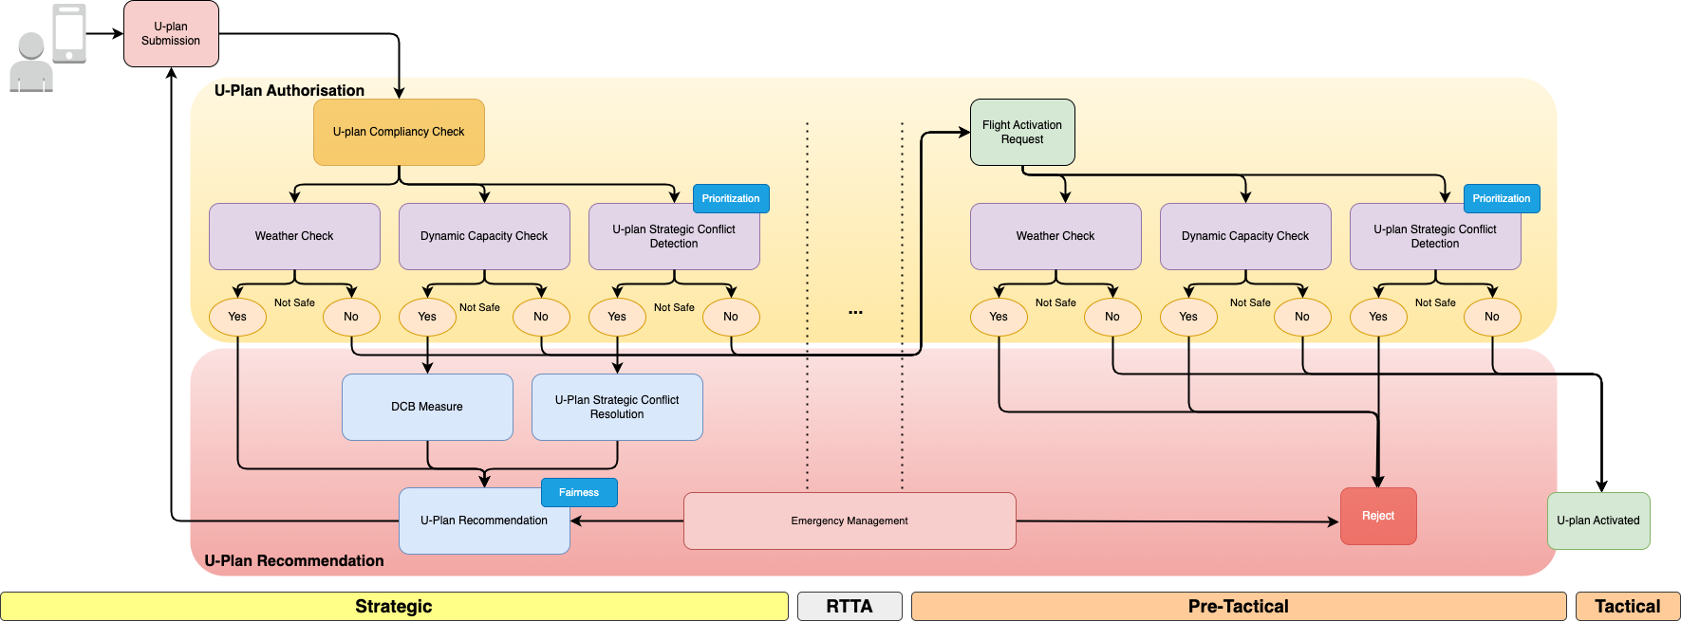

Figure 1. Autonomous Flight Plan Approval System process flow: Including U-plan Authorization and U-plan Recommendation

Compliance with operational limitations related to ground risk is considered during the preparation and submission of the UAS flight authorization request, in accordance with Article 10 of Implementing Regulation (EU) 2021/664. The U-space service provider (USSP) evaluates whether the proposed flight operation complies with applicable constraints, including those associated with ground risk, based on data such as ground risk layers, population density, critical infrastructure, and any other relevant aeronautical or environmental information made available through common information services (as per Article 6 and Annex III). These checks may be performed as part of the U-plan Compliancy Check, which is currently considered out of scope for the AI4HyDrop project.

## Integration with Other U-space Services

The Autonomous Flight Plan Approval System (A-FPLAS) is designed to streamline the submission, evaluation, and approval of unmanned aerial vehicle (UAV) flight plans within controlled airspace. At its core, the system encompasses several critical components: a validation mechanism to ensure compliance with airspace regulations, strategic conflict prediction and resolution tools to identify and mitigate potential flight plan conflicts, and a U-plan Recommendation System that suggests optimized routes based on the analysis of submitted data. This integrated functionality ensures safe and efficient UAV operations.

A-FPLAS operates with input from various external data sources and systems that provide the necessary information for informed decision-making. Aeronautical Information Services (AIS) and Drone AIS (DAIS) supply up-to-date airspace information, including restricted zones and capacity limits, with hourly updates. Weather information systems contribute essential data, such as wind predictions, which are critical for flight planning. Dynamic Capacity Management continuously monitors and adjusts airspace capacity in real-time to reflect current traffic and situational demands.

The workflow begins with operators preparing flight plans tailored to their operational objectives and constraints. These U-plans are submitted to A-FPLAS for processing and approval, which typically occurs within minutes. If conflicts or issues are identified during the review process, the system facilitates negotiations between operators to resolve these conflicts. Once finalized and approved, U-plans are shared with relevant stakeholders, such as Air Traffic Control (ATC) and emergency management systems, to ensure seamless integration with existing air traffic management structures.

A-FPLAS also incorporates support for UAV registration and operator identification, further enhancing system security and accountability. Throughout the process, updates from external systems, such as hourly weather forecasts or dynamic airspace changes, ensure that the system remains responsive to evolving conditions. By enabling real-time analysis and strategic decision-making, A-FPLAS plays a vital role in maintaining the safety, efficiency, and scalability of UAV operations in increasingly complex airspace environments.

The diagram below illustrates the functional architecture and integration flow of A-FPLAS, highlighting its core components, external dependencies, and operational processes.



Figure 2. Connection of Autonomous Flight Plan Approval System (A-FPLAS) with other U-space Services

The following table provides an overview of the main actors involved in the U-space ecosystem and outlines their respective responsibilities and actions across the drone flight planning and execution process. These roles are defined in alignment with the operational and technical framework established under Implementing Regulation (EU) 2021/664, which governs the provision of U-space services within designated U-space airspace.

A central focus of the table is the functions of A-FPLAS process (often referred to as UAS flight authorisation), as specified in Article 10 of the Regulation. This process is coordinated by the U-space service provider (USSP) and involves validating the proposed operation, checking compliance with airspace constraints and operational limitations, and ensuring strategic deconfliction with other UAS operations. Once authorised, the U-plan becomes the reference for execution, and any modification requires a formal revision. The information exchange and interoperability among these entities are typically coordinated via the common information services, as described in Articles 5–7 of the Regulation. However, in cases where a Common Information Service Provider (CISP) is not designated by the Member State, the involved stakeholders are expected to establish secure and interoperable peer-to-peer interfaces to fulfil the same obligations.

Table 5. Autonomous Flight Plan Approval Functions and Responsibilities

|  |  |  |
| --- | --- | --- |
| Role / Service Node | Responsibility | Actions and Responsibilities |
| Operational U-Plan Preparation | UAS operator or designated ground-control crew, typically via software or mobile applications | - Submits, modifies, or cancels U-plans.  - Activates or ends U-plans.  - Receives confirmation or rejection notifications.  - Requests information about U-plans or their current status.  - Receives alerts about changes in U-plan status.  - May utilize a U-plan preparation or optimization tool. |
| Aeronautical Information Service  Drone Aeronautical Information Service | National AIS provider / typically ANSP | - Provides aeronautical publications (e.g., charts, maps).  - Delivers NOTAMs (Notices to Airmen).  - Low-altitude obstacle DB, vertiports, ground risk layers. |
| Local AIS provider / ANSP; data typically distributed via CISP or USSP cache. If CISP is unavailable, USSPs must ensure direct access to updated AIS data sources and NOTAMs. |
| Registration Service | National Aviation Authority or delegated entity | - Validates the operator, pilot credentials, and drone type specified in the U-plan. |
| Dynamic Capacity Management Service | USSP (may use capacity figures from ANSP / Network Manager through CISP. Without CISP, USSPs must establish direct data-sharing links with ANSPs to access latest capacity figures.) | - Detects and addresses imbalances between demand and airspace capacity.  - May adjust the U-plan status to manage capacity constraints. |
| Network Identification Service | USSP managing the operator's flight; supports inter-USSP exchange | - Queries U-plans, their identifiers, and current states.  - Creates, updates, or terminates flight surveillance sessions linked to a U-plan. |
| Weather Information Service | Certified MET provider; often redistributed via CISP or directly to USSP. In absence of CISP, each USSP must query MET providers directly or maintain a contractual link for access. | - Provides weather forecasts and alerts. In AI4HyDrop project, this includes wind turbulence prediction for urban environment. |
| Interface with ATC | Coordination initiated by USSP; ANSP/ATC responds; CISP is backbone. | - Initiates coordination for flights entering controlled airspace. |
| Strategic Conflict Prediction Service | USSP | - Dynamically identifies potential conflicts between U-plans prior to flight. This includes monitoring flight priorities. |
| Strategic Conflict Resolution Service | USSP | - Resolves identified conflicts before the flight begins. In AI4Hydrop, named as U-Plan Recommendation Module (as a part of Autonomous Flight Plan Approval Service (A-FPLAS) Solution 0450), uses AI to provide resolution recommendations along with their explanations. This includes fairness considerations. |
| Strategic Emergency Management Service | USSP (triggers from operator, ANSP, police, etc., via CISP. Without CISP, emergency triggers must be routed to USSPs via direct protocol-based channels with the competent authorities.). | - In case of emergency (identified automatically or initiated), it may adjust the U-Plans statutes. This may be supplied via Strategic Conflict Prediction Service, or in AI4HyDrop, U-Plan Recommendation Module as a part of Autonomous Flight Plan Approval Service (A-FPLAS) Solution 0450. |

## Conflict Detection Framework

In the context of flight plan approval and conflict resolution, **A-FPLAS** employs a structured decision-making framework that decomposes the problem into three hierarchical levels. At the **high level**, strategic decisions are made, such as whether to approve, modify, or reject flight plans. At the **mid- level**, the system determines the appropriate conflict resolution strategy—either re-routing the trajectory or adjusting its schedule. Finally, at the **low level**, detailed decisions are made, such as the specific direction for re-routing or the precise method for modifying the schedule. This hierarchical structure allows the system to address multiple objectives, balancing safety, efficiency, compliance, fairness, and cost. By enabling scalable and adaptive solutions, A-FPLAS is particularly well-suited to the dynamic nature of U-space operations, providing a robust framework to ensure operational efficiency and stakeholder trust.

Following the framework established in Implementing Regulation (EU) 2021/664, this study categorizes 4D trajectories into two types: area-based and linear trajectories. Area-based trajectories consist of a single volume capturing the UAS's movements within a defined time window, suitable for tasks like surveillance or inspection. Linear trajectories, in contrast, comprise interconnected volumes with slight spatial overlaps, ideal for point-to-point operations such as transport.

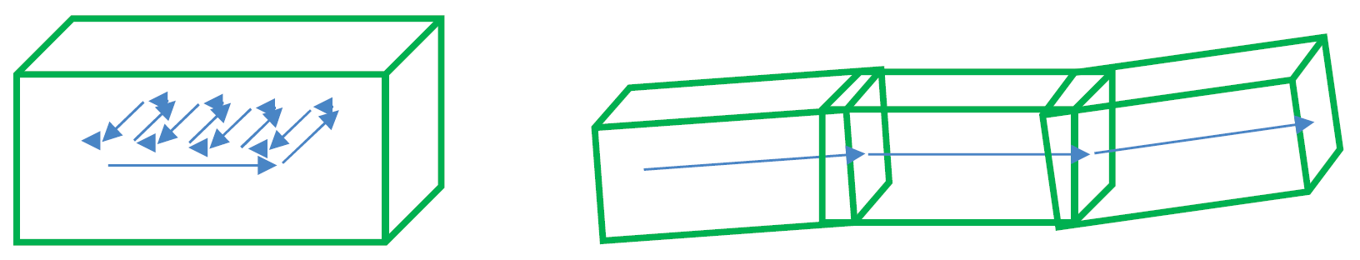

Figure 3. The left represents an area-based trajectory; the right depicts a linear trajectory [1].

Therefore, we consider here three types of waypoints: take-off waypoints, checkpoint waypoints, and landing waypoints. These waypoints are critical for defining the spatial characteristics of the 4D volumes. For linear trajectories, waypoints are positioned at the centers of the entry and exit faces of each volume, with a slight inward offset from the volume boundaries. The midpoint between these waypoints defines the volume's center, while the line connecting them determines its orientation. To ensure spatial continuity, the exit waypoint of one volume also serves as the entry waypoint for the subsequent volume, maintaining the required overlap between volumes.

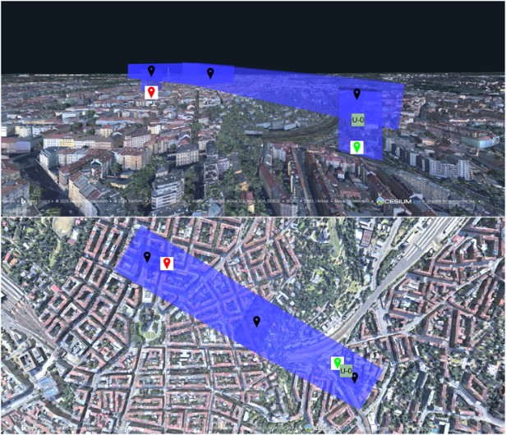

Figure 4. Top and front views of a linear trajectory. UAS 0 (U-0) is positioned within the first volume of the trajectory. The UAS starts from the take-off waypoint (green) and lands at the landing waypoint (red).

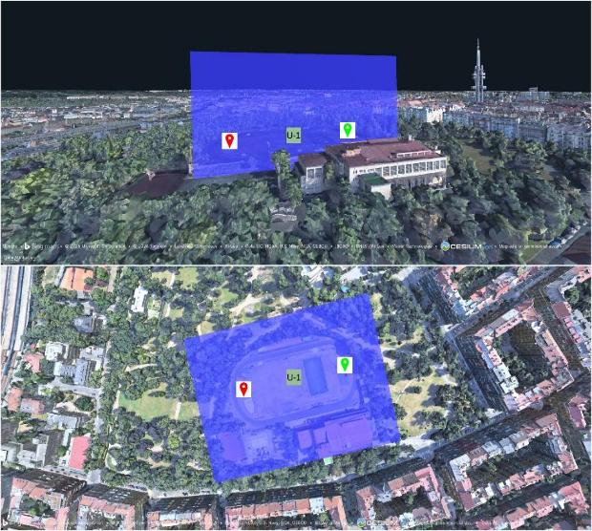

Figure 5. Top and front views of an area-based trajectory. The take-off waypoint (green) and landing waypoint (red) partially define the geometry of the volume.

Conflict detection involves identifying overlaps between the 4D volumes of two or more trajectories, which include three-dimensional spatial coordinates along with the temporal dimension. This process is crucial for ensuring safe and efficient operations in airspace shared by multiple Unmanned Aerial Systems (UAS). Figure 6 illustrates a simulated UAS traffic scenario with multiple UASs operating along their respective trajectories, showcasing the complexity of managing air traffic in environments with diverse operational demands.

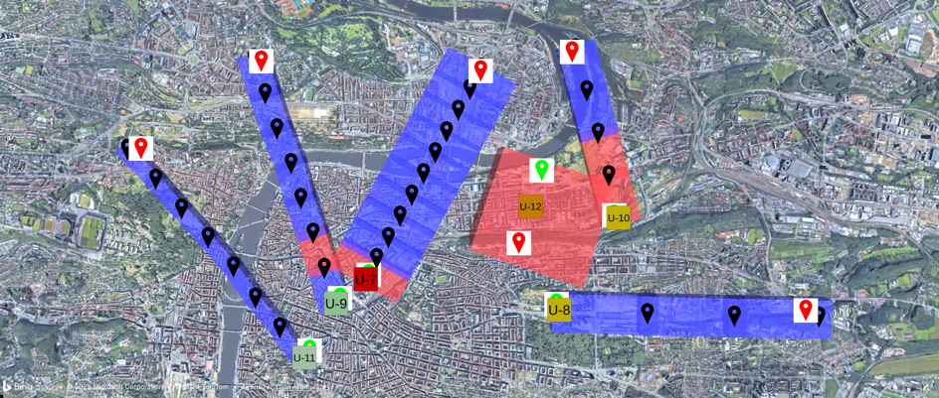

Figure 6. Simulated UAS traffic scenario. Conflicting volumes are highlighted in red, while conflict-free volumes are shown in blue.

In this scenario, the third volume of UAS 9 (U-9)'s linear trajectory overlaps with the second volume of UAS 7 (U-7)'s linear trajectory, resulting in a conflict in both geometry and occupancy time. Similarly, the area-based trajectory of UAS 12 (U-12) conflicts with both the second and third volumes of UAS 9's linear trajectory, highlighting the intricate interactions that can arise in multi-UAS operations.

To resolve these conflicts, flight authorization system evaluate U-plans according to operational priority and submission time. This evaluation process is critical, as it helps maintain safety while optimizing airspace usage. For example, a medical delivery drone may be prioritized over a recreational UAS due to the urgent nature of its mission. Moreover, advanced algorithms are employed to enhance conflict detection and resolution.

The formulation of dimensions for 4D volumes is thoroughly covered in the JARUS Guidelines on Specific Operations Risk Assessment (SORA) document.

## Autonomous Flight Plan Recommendation Approach

Current flight plan approval processes rely heavily on manual evaluations, which are effective only for low traffic volumes. These methods are inherently slow, error-prone, and unable to scale with the rapidly growing number of UAV operations. While automated systems have been proposed to streamline these processes, most rely on static, rule-based approaches that lack adaptability to the dynamic nature of U-space. Factors such as changing weather conditions, fluctuating airspace usage, and varying operator priorities require a more flexible and intelligent solution.

One of the most pressing challenges in U-space management is resolving flight plan conflicts caused by overlapping 4D trajectories. These conflicts increase the risk of collisions and operational inefficiencies, necessitating a system capable of generating safe, fair, and conflict-free alternative flight plans. Addressing this issue requires balancing safety, operational efficiency, and the interests of UAV operators, uninvolved people on the ground, and flight authorization authorities.

As UAV traffic continues to rise and autonomy becomes more prevalent, AI presents a powerful tool to address these challenges. AI can not only analyze the underlying reasons for flight plan rejections but also facilitate efficient negotiations between the approval system and operators. AI4HyDrop investigates the potential of AI-driven solutions to enhance U-space management by providing an intelligent U-plan recommendation system. This approach ensures that flight approvals are processed swiftly and fairly, optimizing airspace utilization while maintaining safety and compliance with regulatory frameworks. Please note that, throughout this document, U-Plan and Flight Plan are used interchangeably.

### Structure of Flight Plan Recommendation

A-FPLAS receives and verifies the UAS flight authorization request, commonly referred to as the U-plan, submitted by the operator. According to the Implementing Regulation (EU) 2021/664, Annex IV, the U-plan must include specific information to ensure compliance and safety in U-space operations. The required fields and their descriptions are provided in Section 3.1. Upon receiving the U-plan, the process follows a number of steps to evaluate its approvability, as outlined in Section 4.2.

The U-plan Approval System plays a critical role in ensuring compliancy. Specifically, the A-FPLAS can automate the initial checks to verify that a U-plan meets both syntax and semantic requirements. Moreover, it can facilitate the operation risk assessment, if required, and validate the eligibility of the UAS, its pilot, and its operator by interfacing with a registry database. The system is also capable of assessing the credibility of the 4D trajectory, confirming that weather conditions are suitable for the planned operation, and ensuring compliance with geofencing requirements.

The procedural interface with Air Traffic Control (ATC) can be managed by the A-FPLAS. This step is crucial for ensuring that UAS operations in controlled airspace are coordinated with ATC.

The responsibility for dynamic capacity management lies solely with the flight authorization authority. As outlined in U-space ConOps and Architecture (Edition 4), this process is typically conducted close to the U-plan's activation time to take advantage of a more accurate and reliable traffic picture. This time, referred to as the Reasonable Time to Act (RTTA), varies based on operational needs and can range from five minutes to less than one minute before the U-plan activation.

In conflict management, conducted at the RTTA, the process performs a final check to identify any trajectory conflicts with other U-plans. If no conflicts are detected, the U-plan is approved. However, if a conflict is identified, the process evaluates both the submission time of the U-plan and the priority of the operation to determine whether an alternative trajectory should be proposed or if the operation can still be approved.

The process approves the operation with higher priority and chooses to propose an alternative trajectory for the other operation. In cases where both operations have the same priority, the process approves the one with the earlier U-plan submission time and chooses to propose an alternative trajectory for the other operation.

AI4HyDrop solution for U-plan Recommendation proposes a Hierarchical Reinforcement Learning (HRL)-based framework to tackle these challenges. The framework employs a two-level hierarchy of agents to manage strategic decisions, optimize operational aspects, and fine-tune adjustments. It integrates a decomposed reward function to balance safety, efficiency, compliance, fairness, and cost while leveraging SHapley Additive exPlanations (SHAP) for enhanced interpretability and stakeholder trust.

### Flight Plan Recommendation Agent

As illustrated in Figure 7, when the approval decision process decides to propose a modified trajectory, the strategy selector agent determines the most appropriate deconfliction strategy. This agent decides between modifying the position of the waypoints of the volume(s) in conflict and changing the departure or arrival time of the UAS. This agent makes this decision based on the inputs detailed in Table 6.

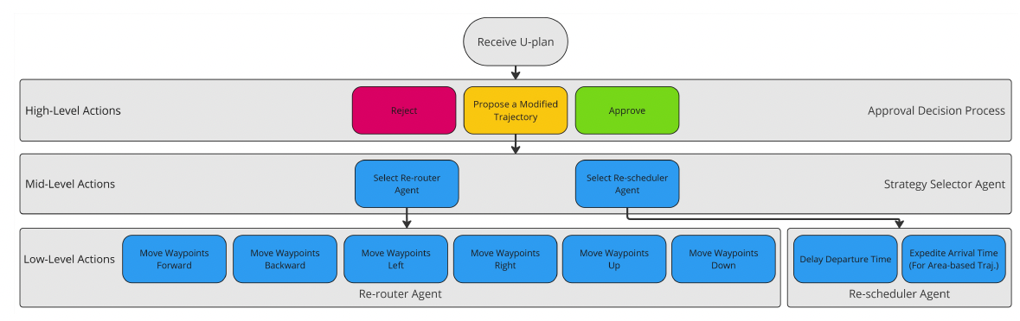

Figure 7. Hierarchical Action Structure of U-plan Recommendation System

Table 6. State Variables of the Strategy Selector Agent

|  |  |  |
| --- | --- | --- |
| Variable | Type | Description |
| $$p_{o}$$ | Continuous (0-1) | Operator's preference for preserving trajectory geometry vs. timing. |
| $$p_{gc}$$ | Continuous (0-1) | Proportion of this trajectory's volumes that are geometrically in conflict with the other trajectory. |
| $$p_{tc}$$ | Continuous (0-1) | Proportion of this trajectory's volumes that are temporally in conflict with the other trajectory. |
| $$t_{to}$$ | Categorical (0/1) | Type of this trajectory (0: Linear, 1: Area-Based). |
| $$t_{oo}$$ | Categorical (0/1) | Type of the other trajectory (0: Linear, 1: Area-Based). |
| $$d_{gp}$$ | Continuous (0-1) | Depth of Geometrical Penetration: A normalized indicator of how close the center of the geometrical conflict is to the center (or centerline, if the other trajectory is linear) of the other trajectory. |
| $$d_{tp}$$ | Continuous (0-1) | Depth of Temporal Penetration: A normalized indicator of how close the center of the conflict period is to the center of the other trajectory's operation duration. |

$p_{o}$: operator's preference $\left(p_{o}\right)$ as part of the U-plan content. This variable quantifies the operator's priority for preserving either the geometry or the timing of their requested trajectory:

* $p_{o}=0$: Indicates a strong preference for preserving the geometry of the trajectory.
* $p_{o}=1$: Indicates a strong preference for preserving the scheduled departure/arrival time.

As shown in Figure 8, this preference can be represented through a slider user interface. In the illustrated example, the operator has set the preference to 0.7, indicating a stronger inclination to preserve the timing of the trajectory rather than its geometry. This operator's preference resembles the definition of the Cost Index (CI), a term commonly recognized in the ATM community.

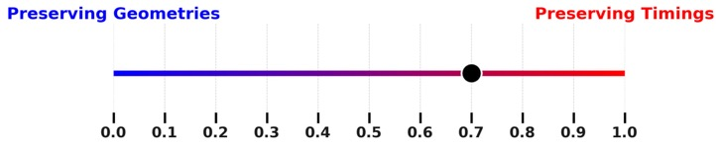

Figure 8. Operator's Preference for Trajectory Modifications during the U-plan Recommendation Process

$p_{gc}$ and $p_{tc}$: The variables $p_{gc}$ and $p_{tc}$ are critical for the strategy selector agent in assessing potential conflict resolution strategies.

* $p_{gc}$: This variable measures the estimated portion of the trajectory’s volumes that geometrically overlaps with those of another trajectory. For example, if approximately $70\%$ of the volumes is in geometrical conflict ( $p_{gc}=$ 0.7), the agent may determine that repositioning the waypoints would require significant alterations to the volume's geometry, potentially leading to unfair outcomes for the operator.
* $p_{tc}$: This variable quantifies the estimated portion of a volume's occupancy time that overlaps with the other volume's occupancy time. For instance, if a volume in an area-based trajectory has a 20 -minute occupancy time, while the other volume occupies the same space for only 1 minute ( $p_{tc}=0.05$), the agent may conclude that adjusting the departure or arrival times, or both, could be an effective solution.

$t_{to}$ and $t_{oo}$: The variables $t_{to}$ and $t_{oo}$ represent the types of trajectories involved in the conflict. Specifically:

* $t_{to}$: The type of the trajectory that should be modified.
* $t_{oo}$: The type of the other trajectory that is in conflict with the trajectory that should e modified.

These variables are defined as follows:

* $t=0$: Linear trajectory.
* $t=1$: Area-based trajectory.

$d_{gp}$ and $d_{tp}$: The variables $d_{gp}$ and $d_{tp}$ complement the $p_{gc}$ and $p_{tc}$ in assessing if the candidate deconfliction strategy can would require too much alteration to the trajectory.

* $d_{gp}$ = This variable represents the spatial depth of this trajectory's intrusion into the other. A higher value of $d_{gp}$ suggests that geometric modifications may be more disruptive or less practical. For instance, in two conflicts with the same $d_{gp}$, a linear trajectory might intersect an area-based trajectory near its boundary (resulting in a low $d_{gp}$), or closer to its center (resulting in a high $d_{gp}$). The latter scenario typically requires more substantial rerouting to resolve the conflict.
* $d_{tp}$ = This variable reflects how close the center of the temporal conflict period is to the midpoint of the other trajectory’s operation duration. It complements $d_{tp}$ by indicating how centrally the conflict is located within the temporal span of the affected operation. For instance, in two scenarios where an area-based trajectory conflicts with a linear one (and the area-based trajectory must be adjusted), the $d_{tp}$ values might be identical. However, in one case, the conflict could occur near the start or end of the operation window (low $d_{tp}$), while in the other, it might occur closer to the midpoint (high $d_{tp}$). The latter typically demands more substantial scheduling adjustments to resolve the conflict.

Table 7 summarizes the reward decomposition for this agent.

Table 7. Reward Components for the Strategy Selector Agent

|  |  |  |
| --- | --- | --- |
| Component | Type | Description |
| $$R_{o}^{S}$$ | Continuous (0-1) | Measures alignment with the operator's preference. |
| $$R_{s}^{S}$$ | Continuous (0-1) | Normalized measure of how similar the proposed trajectory is to the operator’s originally intended plan. |

$R_{o}^{S}$: This component rewards the strategy selector agent based on how well its decision aligns with the operator's preference $\left(p_{o}\right)$, and it is quantified as follows:

$$R_{o}^{S}=\left\{\begin{matrix}\left(1-p_{o}\right), & \text{ (If this agent chooses the re-scheduler agent) } \\ p_{o}, & \text{ (If this agent chooses the re-router agent) }\end{matrix}\right.$$

This ensures reflecting the operator's priorities in the reward calculation.

$R_{s}^{S}$. This component quantifies how closely the proposed trajectory, in both geometry and timing, aligns with the operator’s originally intended plan.

With the decomposition detailed above, the total reward for the strategy selector agent $R_{T}^{S}$ can be quantified as follows:

$$R_{T}^{S}=w_{1}^{S}R_{o}^{S}+w_{2}^{S}R_{s}^{S}$$

where $w_{1}^{S}$ and $w_{2}^{S}$ are the weights assigned to each reward component, reflecting their relative importance.

### Re-router Agent

This agent attempts to resolve conflicts by adjusting the positions of the waypoints associated with the conflicting volume(s). It is important to note that as waypoint positions change, the length of a volume may also change. Given a constant flight speed, this updated length will result in a new occupancy time for the volume—and subsequently for all following volumes. This change may lead to a delayed or expedited arrival time. However, such timing shifts are a byproduct of spatial modification and should not be mistaken for intentional delays or advancements initiated by the re-scheduler agent, which explicitly manages temporal adjustments.

The re-router agent modifies the trajectory by repositioning checkpoint waypoints of all conflicting volume(s) in a local coordinate system. The agent’s action space consists of six discrete actions, summarized in Table 8.

Table 8. Action Space of the Re-router Agent

|  |  |  |  |
| --- | --- | --- | --- |
| Action | Entry Waypoint | Exit Waypoint | Displacement Direction |
| 1 | Forward | Forward | $${\overset{ˆ}{X}}_{\text{local }}$$ |
| 2 | Backward | Backward | $$-{\overset{ˆ}{X}}_{\text{local }}$$ |
| 3 | Left | Left | $${\overset{ˆ}{Y}}_{\text{local }}$$ |
| 4 | Right | Right | $$-{\overset{ˆ}{Y}}_{\text{local }}$$ |
| 5 | Up | Up | $${\overset{ˆ}{Z}}_{\text{local }}$$ |
| 6 | Down | Down | $$-{\overset{ˆ}{Z}}_{\text{local }}$$ |

The forward direction (${\overset{ˆ}{X}}_{\text{local }}$) of the mentioned local frame of reference for these movements is constructed as follows:

* If an area-based trajectory must move away from another area-based trajectory, ${\overset{ˆ}{X}}_{\text{local }}$ would be the unit vector along the longest horizontal axis (length or width) of the other conflicting trajectory, originating from its center.
* If an area-based trajectory must move away from a linear trajectory, ${\overset{ˆ}{X}}_{\text{local }}$ would be the unit vector along a horizontal line segment starting at the take-off waypoint of the linear trajectory and directed toward its landing waypoint.
* If a linear trajectory must move away from another linear trajectory, ${\overset{ˆ}{X}}_{\text{local }}$ would be the unit vector along the line segment that connects the take-off point to the landing point of the trajectory that should be modified.
* If a linear trajectory must move away from an area-based trajectory, similar to the previous scenario, ${\overset{ˆ}{X}}_{\text{local }}$ must align with the segment from the take-off point to the landing point of the trajectory that should be modified.

Given ${\overset{ˆ}{X}}_{\text{local }}$ ​, the vector ${\overset{ˆ}{Y}}_{\text{local }}$ ​lies horizontally along the ground plane and points to the left. Assuming a right-handed local frame, the resulting ${\overset{ˆ}{Z}}_{\text{local }}$ ​ then points upward relative to the ground.

By defining movement directions within this trajectory-aware local frame, the re-router agent ensures that repositioning actions remain aligned with the operational structure of the trajectories, are effective in mitigating conflicts, and maintain an intuitive flow consistent with expected movement patterns.

To determine the magnitude of movement in a given direction, this study proposes an adaptive step-size approach based on the severity of the conflict. The displacement magnitude $m$  is formulated as:

$$m= λWp_{gc}$$

where $W$ is the width of the volume(s) in conflict, and $λ$ is a constant coefficient.

This formulation ensures that the movement responds to the severity of the conflict, allowing for greater adjustments when the overlap $p_{gc}$ is more significant.

State variables of the agent are summarized in Table 9.

Table 9. State Variables of the Re-router Agent

|  |  |  |
| --- | --- | --- |
| Variable | Type | Description |
| $$p_{gc}$$ | Continuous (0-1) | Proportion of this trajectory's volumes that are geometrically in conflict with the other trajectory. |
| $$Δ_{gc}$$ | Continuous (0-1) | Improvement in the geometrical conflict, normalized based on the minimum and maximum reductions achievable across all possible actions. |
| $$Δ_{gs}$$ | Continuous (0-1) | Preservation of geometrical similarity to the operator's intended trajectory, normalized based on the minimum and maximum similarity preservation achievable across all possible actions. |
| $$Δ_{ρ}$$ | Continuous (0-1) | Improvement achieved by repositioning the trajectory's volumes over less populated areas, normalized based on the minimum and maximum improvements achievable across all possible actions. |
| $$Δ_{d}$$ | Continuous (0-1) | Continuous (0--1) & Improvement achieved by horizontally repositioning the trajectory away from high-demand zones, normalized based on the minimum and maximum improvements achievable across all possible actions |
| $$Δ_{{\overset{‾}{T}}_{ρ}}$$ | Continuous (0-1) | Improvement in the sum of volumes’ occupancy times weighted by the population density beneath each volume, normalized based on the minimum and maximum achievable improvements across all possible actions. |
| $$Δ_{{\overset{‾}{H}}_{ρ}}$$ | Continuous (0-1) | Improvement in the sum of volumes’ height weighted by the population density beneath each volume, normalized based on the minimum and maximum achievable improvements across all possible actions. |

$Δ_{gc}$: This variable helps the agent evaluate whether its actions are reducing the overlap, which is crucial for resolving conflicts.

$Δ_{gs}$: The variable reflects how closely the modified volume(s) of a trajectory resemble the original volume(s) in terms of geometry. To compute $Δ_{gs}$, the modification of each volume geometry, denoted as $d_{gs}$, is formulated as follows:

$$d_{gs}= αd_{\text{scale }}+βd_{\text{orientation }}$$

where $d_{\text{scale }}$ quantifies the relative change in the scale components ($x,y,z$) through:

$$d_{\text{scale }}=\frac{1}{3}\left(\frac{\left|x_{\text{mod }}-x_{\text{orig }}\right|}{x_{\text{orig }}}+\frac{\left|y_{\text{mod }}-y_{\text{orig }}\right|}{y_{\text{orig }}}+\frac{\left|z_{\text{mod }}-z_{\text{orig }}\right|}{z_{\text{orig }}}\right)$$

where the indices mod and orig refer to the modified quantity and its original value respectively.

The $d_{\text{orientation }}$ can be quantified using:

$$d_{\text{scale }}=\frac{arccos⁡\left(\frac{{\vec{V}}_{\text{orig }}⋅{\vec{V}}_{\text{mod }}}{∥{\vec{V}}_{\text{orig }}∥∥{\vec{V}}_{\text{mod }}∥}\right)}{π}$$

where $\vec{V}$ is the vector connecting the entry anchor of the volume to its exit anchor.

The $α$ and $β$ are weights balancing the contributions of $d_{\text{scale }}$ and $d_{\text{orientation }}$ respectively.

$Δ_{ρ}$: This variable is an estimation of the population density beneath the trajectory's volume(s). In the absence of open-access, high-resolution, and globally consistent population density datasets—which are typically acquired through national census data, satellite imagery analysis, and mobile network activity logs—we opted to use the Cesium-provided OpenStreetMap (OSM) Buildings layer as a proxy. This layer renders only the buildings located directly below each volume.

As illustrated in Figure 9, the density of non-background-colored pixels in the rendered image can serve as a rough approximation for population density—assuming that the aspect ratio of the virtual camera is configured to capture only the area directly beneath the volume. The underlying assumption is that regions with a high concentration of buildings are likely to correspond to areas with higher population density.

Naturally, this approach does not account for locations with low building density but high population density, such as highways, open-air event venues, or temporary gathering areas for concerts and festivals. However, given the lack of comprehensive and openly accessible population datasets suited for U-space services, this method offers a practical and scalable alternative. Once more accurate data becomes available, trained agents can adapt by retraining and fine-tuning their learned policies accordingly.

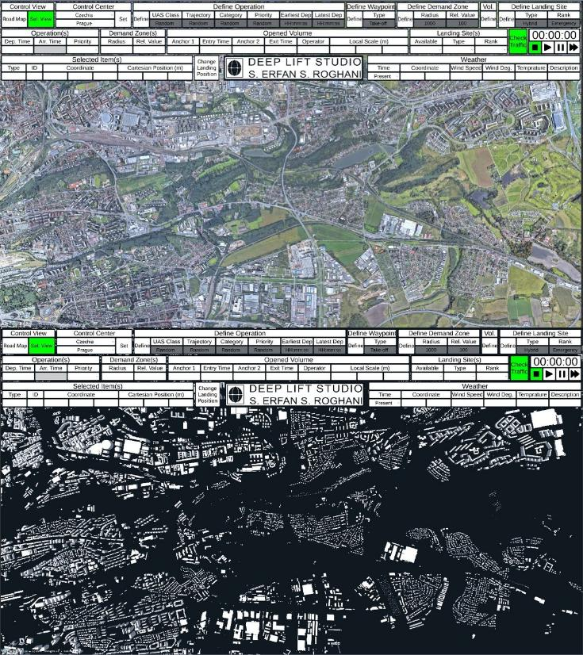

Figure 9. Estimation of population density provided by the OpenStreetMap Buildings layer of Cesium.

$Δ_{d}$: This variable requires an estimation of demand for the regions that encompass each volume of the trajectory. The re-router agent is trained using a synthetic, static demand-zone map that defines high-demand areas within the U-space airspace using cylindrical volumes, as illustrated in Figure 10. Each high-demand zone in Figure 10 is assigned a value within the range (0, 1], quantifying the demand level at the center of the region. Assuming this central value reflects the peak demand, the demand at any other point within the region is estimated by applying a linear reduction, reaching zero at the boundary of the zone. This approach provides a spatially graded approximation of demand and allows for estimating the demand associated with each trajectory volume.

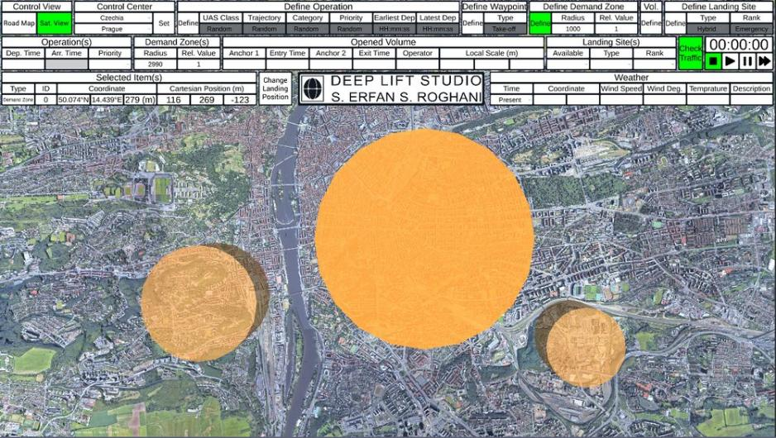

Figure 10. Synthetic static demand zone map.

$Δ_{{\overset{‾}{T}}_{ρ}}$: This variable quantifies the improvement made in population-density-weighted sum of the trajectory’s volumes’ occupancy duration, ${\overset{‾}{T}}_{ρ}$ and is formulated as follows:

$${\overset{‾}{T}}_{ρ}=\sum_{i=1}^{n}{ }ρ_{i}⋅t_{i}$$

Where:

* $ρ_{i}$: Population density below volume $i$.
* $t_{i}$: Occupancy duration of volume $i$.
* $n$: Number of trajectory volumes.

With this formulation, an improvement in ${\overset{‾}{T}}_{ρ}$ reflects a modification that prioritizes relocating volumes with longer occupancy durations to less-populated areas over those with shorter occupancy times.

$Δ_{{\overset{‾}{H}}_{ρ}}$: Similar to $Δ_{{\overset{‾}{T}}_{ρ}}$, this variable quantifies the improvement made in population-density-weighted sum of the volumes’ height, and is formulated as follows:

$${\overset{‾}{H}}_{ρ}=\sum_{i=1}^{n}{ }ρ_{i}⋅h_{i}$$

Where:

* $ρ_{i}$: Population density below volume $i$.
* $h_{i}$: Altitude (height) of volume $i$.
* $n$: Number of trajectory volumes.

With this formulation, an improvement in ${\overset{‾}{H}}_{ρ}$ reflects a modification that prioritizes increasing the altitude of volumes passing over densely populated areas rather than those over less populated regions.

$\backslash * MERGEFORMAT Table 10$ summarizes the reward decomposition for this agent.

Table 10. Reward Components of the Re-router Agent

|  |  |  |
| --- | --- | --- |
| Component | Type | Description |
| $$R_{gc}^{R}$$ | Continuous (0-1) | Reward for reducing the geometrical overlap between conflicting volumes. |
| $$R_{gs}^{R}$$ | Continuous (0-1) | Reward for preserving the geometrical similarity of the modified trajectory to the operator's original plan, including both scale and orientation. |
| $$R_{ρ}^{R}$$ | Continuous (0-1) | Reward for shifting the trajectory over less populated areas. |
| $$R_{d}^{R}$$ | Continuous (0-1) | Reward for moving the trajectory away from high-demand airspace regions. |
| $$R_{Δ_{{\overset{‾}{T}}_{ρ}}}^{R}$$ | Continuous (0-1) | Reward for minimizing flight time over densely populated areas to reduce noise and privacy concerns. |
| $$R_{Δ_{{\overset{‾}{H}}_{ρ}}}^{R}$$ | Continuous (0-1) | Reward for increasing flight height over densely populated areas to reduce noise and protect privacy. |

The relationship between the components of the reward for the re-router agent is detailed as follows:

$$\begin{matrix}R_{gc}^{R} & =Δ_{gc} \\ R_{gs}^{R} & =Δ_{gs} \\ R_{ρ}^{R} & =Δ_{ρ} \\ R_{d}^{R} & =Δ_{d} \\ R_{Δ_{{\overset{‾}{T}}_{ρ}}}^{R} & =Δ_{{\overset{‾}{T}}_{ρ}} \\ R_{Δ_{{\overset{‾}{H}}_{ρ}}}^{R} & =Δ_{{\overset{‾}{H}}_{ρ}}\end{matrix}$$

With the components detailed above, the total reward for the re-router agent $R_{T}^{R}$ can be quantified as:

$$R_{T}^{R}=w_{1}^{R}R_{gc}^{R}+w_{2}^{R}R_{gs}^{R}+w_{3}^{R}R_{ρ}^{R}+w_{4}^{R}R_{d}^{R}+w_{5}^{R}R_{Δ_{{\overset{‾}{T}}_{ρ}}}^{R}+w_{6}^{R}R_{Δ_{{\overset{‾}{H}}_{ρ}}}^{R}$$

where $w_{1}^{R},…,w_{6}^{R}$ are weights assigned to each reward component, reflecting their relative importance. These weights can be adjusted based on specific operational preferences. For instance, in a highly congested U-space environment, a higher weight might be assigned to minimizing geometrical overlaps, while in urban or sensitive areas, minimizing flight time over populated regions may be prioritized. For the purposes of validation in this study, we have chosen to assign equal weights to all components, i.e., $w_{1}^{R}=…=w_{6}^{R}=\frac{1}{6}$.

### Re-scheduler Agent

The Re-scheduler Agent resolves the conflict by changing the schedule of the operation, and its action space is summarized in Table 11.

Table 11. Action Space the Re-scheduler Agent

|  |  |  |
| --- | --- | --- |
| Action | Trajectory Type | Description |
| 1 | Linear / Area-based | Delays the operation by $t_{d}$ |
| 2 | Area-based only | Expedites the arrival time of the operation by $t_{e}$ |

The $t_{d}$ and $t_{e}$ in Table 11 are in fact the state variables of the re-scheduler agent and they are summarized in Table 12.

Table 12. State Variables of the Re-scheduler Agent

|  |  |  |
| --- | --- | --- |
| Variable | Type | Description |
| $$t_{d}$$ | Continuous | Minimum required delay (in seconds) to fully resolve the temporal conflict. |
| $$t_{e}$$ | Continuous | Minimum required expedite in arrival time (in seconds) to fully resolve the temporal conflict (only applicable for area-based trajectories). |

Table 13 summarizes the reward decomposition for this agent.

Table 13. Reward Component of the Re-scheduler Agent

|  |  |  |
| --- | --- | --- |
| Component | Type | Description |
| $$R_{d}^{T}$$ | Continuous | Reward for minimizing the modification of the departure time, encouraging minimal deviation from the original schedule. |
| $$R_{a}^{T}$$ | Continuous | Reward for minimizing the modification of the arrival time, ensuring the operation schedule is preserved. Only applicable to area-based trajectories. |
| $$R_{l}^{T}$$ | Continuous | Reward for reducing the total operation duration, encouraging shorter operations to benefit other operators, and reducing exposure to people on the ground. |

The components in Table 13 are formulated as follows:

$$\begin{matrix}R_{d}^{T} & =1-\frac{t_{d}}{T_{orig}} \\ R_{a}^{T} & =1-\frac{t_{e}}{T_{\text{orig }}} \\ R_{l}^{T} & =\frac{T_{mod}}{T_{\text{orig }}}\end{matrix}$$

Where $T_{\text{orig }}$ is the total duration of the operation before modification, and $T_{mod}$ is the amount of time reduced by expediting the arrival time in area-based trajectories.

This decomposition encourages the agent to prefer expediting the arrival time of area-based trajectories to delaying their departure time as, in addition to resolving the conflict, it shortens the duration of the operation, which is in the interest of the people on the ground and other operators planning to conduct operations in that area.

With the components detailed above, the total reward for the re-router agent $R_{T}^{R}$ can be quantified as:

$$R_{T}^{T}=w_{1}^{T}R_{d}^{T}+w_{2}^{T}R_{a}^{T}+w_{3}^{T}R_{l}^{T}$$

where $w_{1}^{T}, w_{2}^{T}, and w_{3}^{T}$ are weights assigned to each reward component, reflecting their relative importance. These weights can be tuned according to operational priorities. For example, in environments where precise scheduling is critical—such as for drone deliveries with tight arrival windows—a higher weight could be assigned to $R_{a}^{T}$ to prioritize minimizing arrival time deviations. Conversely, in dense urban areas where reducing time spent overpopulated regions is more important, $R_{l}^{T}$ might be weighted more heavily to encourage shorter operations. For the purpose of validation in this study, we assigned equal importance to all components by setting $w_{1}^{T}=w_{2}^{T}=w_{3}^{T}=\frac{1}{3}$. This provides a balanced optimization strategy that does not bias the agent toward any single objective.

### Fairness and Prioritization Concept in Drone Flight Plan Approval

Fairness in UTM is a critical aspect that ensures equitable access to airspace and services, minimizing operational conflicts and monopolization by specific stakeholders. Properly defined fairness metrics are essential for evaluating and maintaining balance in airspace management. This section provides a structured approach to defining, measuring, and analyzing fairness in UTM through mathematical formulations and key performance indicators. The following metrics might provide defining, measuring, and analyzing fairness in UTM through mathematical formulations and key performance indicators.

#### Average, Total, and Maximum Allocated or Incurred Delay Minutes

In the context of U-Plan replanning, **delays** refer to additional time incurred by an operation due to factors such as airspace congestion, traffic conflicts, or negotiation processes for conflict resolution. The **allocated or incurred delay minutes** metrics help evaluate fairness in UTM by tracking how delays are distributed among operators.

**Average Delay (AD)**

Measures the mean delay experienced across all operations.

$$AD=\frac{\sum_{i=1}^{N}{ } D_{i}}{N}$$

where $D_{i}$ is the delay in minutes for operation $i$ and $N$ is the total number of operations.  
**Total Delay (TD)**

Sums all delays across all operations, providing a cumulative delay impact metric.

$$TD=\sum_{i=1}^{N}{ }D_{i}$$

**Maximum Delay (MD)**

Identifies the highest single delay experienced by any operation.

$$MD=max\left(D_{i}\right)$$

where $D_{i}$ is the delay in minutes for operation $i$.

#### Number of Negotiations and Successful Outcomes

Operational conflicts might be resolved through negotiations between stakeholders, such as USSP and drone operator representative. Whenever two or more operational intents overlap or conflict, a negotiation process is initiated to resolve the issue in a fair and efficient manner. Tracking negotiation occurrences and their success rates might help evaluate airspace congestion and fairness in access to airspace resources.

**Total Negotiations (TN)**

Counts the total number of negotiation instances between conflicting operational intents.

$$TN=\sum_{i=1}^{M}{ }N_{i}$$

where $N_{i}$ is each negotiation event and $M$ is the total number of operations that involved negotiation.  
  
**Successful Negotiations (SN)**

Counts negotiations that resulted in a resolution without delay or with mutually acceptable adjustments.

$$SN=\sum_{j=1}^{P}{ }S_{j}$$

where $S_{j}=1$ if negotiation $j$ is successful (resolution reached) and $S_{j}=0$ otherwise, and $P$ is the total number of negotiation instances.

**Success Rate (SR)**

Measures the success rate of negotiations, offering insight into the efficiency of the negotiation process.

$$SR=\frac{SN}{TN}×100\%$$

#### Average Additional Delay per Resolved Negotiation

When two or more operations are in conflict, negotiation processes are initiated to resolve the issue. This often results in operational adjustments, leading to additional delays. The *Average Additional Delay per Resolved Negotiation* quantifies the mean delay incurred as a direct consequence of conflict resolution. Monitoring this metric helps evaluate the overall efficiency of the negotiation mechanism and its impact on operational fairness.

**Average Additional Delay (AAD)**

Calculates the mean delay per negotiation that leads to a conflict resolution.

$$AAD=\frac{\sum_{k=1}^{Q}{ } D_{k}}{Q}$$

where $D_{k}$ is the additional delay incurred due to negotiation $k$, and $Q$ is the total number of resolved negotiations.

#### Number of Delayed, Excessively Delayed, or Cancelled Operations

Fairness in UTM might be handled through tracking the number of delayed, excessively delayed, or cancelled operations. These metrics help quantify the impact of congestion, airspace limitations, and operational constraints on different stakeholders. Monitoring these values provides insights into the effectiveness of air traffic management strategies and highlights any systemic inequities in access to airspace resources.

**Total Delayed Operations (TDO)**

Counts operations that experienced any form of delay.

$$TDO=\sum_{m=1}^{R}{ }I_{m}$$

where $I_{m}=1$ if operation $m$ experienced delay and $I_{m}=0$ otherwise, with $R$ as the total number of operations.

**Excessively Delayed Operations (EDO)**

Counts operations that exceeded a defined threshold of acceptable delay, say $T_{\text{excess }}$ minutes.

$$EDO=\sum_{m=1}^{R}{ }\text{ if }\left(D_{m}>T_{\text{excess }}\right)\text{ then }1\text{ else }0$$

**Rejected Operations (RO)**

Counts the number of operations that were cancelled before completion.

$$RO=\sum_{n=1}^{R}{ }C_{n}$$

where $C_{n}=1$ if operation $n$ was rejected, 0 otherwise, and $R$ is the total number of operations.

Each of these metrics, or a hybrid combination of them, can be used to assess the extent to which further adjustments are needed for a specific operator or company. A higher accumulated fairness metric indicates a greater need for corrective actions to ensure a more balanced and equitable distribution of resources among operators. These corrective actions can be implemented by adjusting the prioritization of flight assignments in cases of flight plan conflicts, facilitating negotiations, and managing real-time coordination to promote fairness in Urban Air Mobility operations. This approach also enables the application of additional measures such as loyalty incentives (e.g. operator without penalty points), encouragement mechanisms (e.g. greener operator), and other prioritization-driven strategies to foster a more equitable operational environment.

### Formulation of Prioritization

In accordance with Article 4 of Implementing Regulation (EU) No $923/2012$, Unmanned Service Suppliers (USSPs) should prioritize UAS conducting special operations to ensure efficient and equitable access to airspace. AI4HyDrop Autonomous Flight Plan Approval System follows similar structure in prioritization. These priority operations include:

1. Police and customs missions
2. Traffic surveillance and pursuit missions
3. Environmental control missions conducted by, or on behalf of, public authorities
4. Search and rescue operations
5. Medical flights
6. Evacuations
7. Firefighting
8. Security exemptions required for flights by heads of State, Ministers, and comparable State functionaries

To integrate these prioritizations into UTM fairness metrics, weighting factors can be assigned to special operations in delay calculations, negotiations, and access decisions. A priority score $\left(P_{s}\right)$ can be introduced to reflect the operational urgency and necessity:

$$P_{s}=W_{i} {+ w}_{f}R_{f}$$

where:

$W_{i}$ represents the priority weight assigned to a specific type of special operation and defined as digits $W_{i}=\{0, 1, 2, ...\}$. Higher the value gives higher the priority. E.g. “0” might be used for a commercial or recreational flight.

$R_{f}$ represents the fairness score, which has been discussed in previous Section.

$w_{f}$ represents the weight assigned to fairness metric and defined as $w_{f}>1$. Therefore, the later term with $w_{f}$ can create additional prioritization levels between the same type of special operations. Hence, e.g., a priority score of a commercial flight might be $P_{s}=0.64$. Higher priority operations receive preferential treatment in airspace allocation and delay minimization strategies. These factors should be incorporated into overall fairness evaluations to balance efficiency with equity in UTM systems. This information is utilized by Strategy Selector Agent, which is defined in Section 3.5.2.

## Use of Explainable AI in Flight Plan Recommendation

As AI-driven decision-making becomes increasingly prevalent in aviation, ensuring transparency and trust in automated systems is crucial. In flight plan recommendation systems, understanding the rationale behind AI-generated decisions allows stakeholders to assess their validity and compliance with operational constraints. Explainable AI (XAI) techniques, such as SHapley Additive exPlanations (SHAP), offer a robust framework for interpreting AI-driven recommendations. By quantifying the contribution of various input features, SHAP enhances both global and local interpretability, providing valuable insights into how key factors—such as weather, airspace restrictions, and UAS characteristics—shape decision-making. This section explains the integration of SHAP into the AI4HyDrop U-plan Recommendation System, demonstrating its role in improving transparency, regulatory compliance, and stakeholder alignment in AI-powered flight planning.

SHAP (SHapley Additive exPlanations) is a powerful explainability tool that enhances transparency in AI decision-making systems by providing both global and local interpretability [24]. Based on cooperative game theory, SHAP assigns an importance value to each input feature, quantifying its contribution to the decision. Global interpretability explains how input features shape the overall policy, while local interpretability focuses on understanding specific recommendations, allowing stakeholders to trace the rationale behind individual decisions.

SHAP (SHapley Additive exPlanations) values are derived from cooperative game theory, specifically from the Shapley value concept, which fairly distributes contributions among players (features) in a game (the model's output). The SHAP formulation for a model's prediction is given as follows:

$$ϕ_{i}=\sum_{S⊆F∖\{i\}}{ }\frac{|S|!(|F|-|S|-1)!}{|F|!}[f(S∪\{i\})-f(S)]$$

where:

* $ϕ_{i}$ is the SHAP value for feature $i$.
* $F$ is the set of all features.
* $S$ is a subset of features excluding $i$.
* $f(S)$ represents the model's output (e.g., prediction) when only the subset $S$ of features is present.
* $|S|$ is the number of features in subset $S$.
* $|F|$ is the total number of features.

The SHAP value $ϕ_{i}$ represents the average marginal contribution of feature $i$ across all possible subsets $S$.

The weighting factor $\frac{|S|(|F|-|S|-1)!}{|F|!}$ ensures fair contribution distribution based on all possible feature orderings.

The term $f(S∪\{i\})-f(S)$ quantifies the difference in model output when feature $i$ is added to subset $S$, capturing its effect on the prediction.

By computing SHAP values for all features, we obtain a comprehensive explanation of how each feature contributes to the model's decision, improving interpretability in Al-based flight plan recommendations.

### Explainable Reinforcement Learning

Integrating SHAP with reinforcement learning (RL) involves a structured approach that enhances the interpretability of AI-driven flight plan recommendations. The process begins with training the RL model, where the agent interacts with the environment and learns to optimize flight plans by maximizing cumulative rewards over multiple episodes. This training phase allows the model to develop an optimal policy based on various factors such as weather conditions, geofenced areas, and mission constraints.

Once the RL model has been trained, SHAP is applied to analyze and explain its decision-making process. By computing SHAP values for different input features, the system can determine the relative impact of each factor on action selection. This interpretability step ensures that key elements, such as adverse weather, restricted airspace, or population density, are transparently accounted for in the model’s recommendations.

SHAP provides insights at both global and local levels. At the global level, it helps identify overarching trends in the RL model’s decisions, such as the predominant influence of weather conditions on trajectory adjustments across all flight plans. At the local level, SHAP explains individual recommendations by showing which features contributed most to a specific decision. For instance, if the RL model suggests increasing altitude for a particular mission, SHAP can reveal that this choice was primarily influenced by high population density and the need to minimize disturbances. By integrating SHAP with RL, flight planning systems become both optimized and explainable, fostering greater transparency, trust, and regulatory compliance in AI-driven aviation applications.

### Parameters of Decision Explanation

In AI4HyDrop U-Plan Recommendation System, SHAP values are applied to the RL agent’s decision-making process to reveal the overall influence of features such as weather conditions, geofenced areas, UAS characteristics, 4D volumes, type of mission, and population density on the policy. For instance:

* Weather: SHAP quantifies how adverse weather conditions influence recommendations, such as adjustments to trajectory timing or altitude.
* Geofenced Areas: The system identifies whether the presence of no-fly zones increases the likelihood of horizontal route adjustments or trajectory reshaping.
* UAS Characteristics: Features such as endurance, weight, and speed directly affect energy consumption and maneuverability, influencing recommendations.
* 4D Volumes: SHAP analyzes the spatial and temporal configuration of volumes, highlighting their role in conflict detection and trajectory optimization.
* Type of Mission: SHAP values reveal how the mission type (transport, surveillance, or inspection) impacts the prioritization of rewards, such as minimizing delays for transport missions or optimizing area coverage for inspections.
* Population Density: High-density areas increase the importance of altitude adjustments and minimizing loitering to reduce ground-level disturbances.

By focusing on these critical input features, the SHAP-based analysis provides actionable insights into the priorities and trade-offs underlying the RL agent's decisions.

For individual flight plan recommendations, SHAP provides a breakdown of how each input feature contributed to the specific decision. For example:

A recommendation to adjust the altitude of a conflicting trajectory might be primarily influenced by the maximum-height reward $R_{h}$ as indicated by its high SHAP value. This decision reflects the goal of minimizing ground-level disturbances like noise or privacy concerns.

A decision to delay the entry time into a volume may have a significant SHAP value for the minimum-postpone reward $R_{p}$, reflecting an effort to avoid delays in other operations.

Integrating SHAP into the RL-based recommendation platform provides several key benefits:

* Transparency and Trust: SHAP explanations build confidence in the system by demonstrating that decisions are rational and aligned with stakeholders’ interests.
* Regulatory Compliance: Authorities can trace how safety and compliance considerations influenced each recommendation, ensuring adherence to regulatory frameworks.
* Stakeholder Alignment: By elucidating the reasoning behind prioritization and adjustments, SHAP mitigates potential disputes among stakeholders and promotes cooperation.
* Error Identification and Correction: SHAP helps uncover unintended biases or errors in the reward structure, allowing timely refinements to the system.

SHAP is a useful tool for explaining model predictions, but its application to Reinforcement Learning (RL) comes with challenges. Since RL operates in a sequential decision-making framework, where each action influences future states and rewards, SHAP may sometime struggle to account for these cascading effects. Additionally, the contribution of features in RL can change dynamically based on the evolving environment, making SHAP values less stable across different states. Another limitation is that SHAP primarily provides instance-based attributions, meaning it may not naturally capture the temporal relationships that are fundamental to RL policies.

# Validation Scenarios and Use Cases

## Scope

The validation exercise for the Automated Flight Plan Approval System framework aims to rigorously test and evaluate the system's capabilities and accuracy in automating the approval process for drone flight plans. The system leverages advanced AI algorithms to assess flight plans against a myriad of criteria including safety margins, air traffic density, no-fly zones, and compliance with regulatory standards.

The exercise is structured in several phases to encompass a variety of scenarios, including urban environments, densely populated areas, and remote locations, dynamic airspace priorities, to ensure the AI system's adaptability and robustness. By targeting TRL2, each phase is simulated real-world-like conditions to challenge the system's decision-making algorithms and its ability to integrate seamlessly with future air traffic management systems.

The scope of validations focuses on several critical aspects to ensure the AI system’s effectiveness and reliability in managing and approving drone flight plans within the Unmanned Traffic Management (UTM) system. The specific objectives include:

**Data Interpretation and Processing:**

* Evaluate the AI system's ability to accurately interpret incoming flight plan data and check for completeness and correctness of all required inputs.
* Test the system's efficiency in processing multiple flight plans simultaneously, ensuring no delays or data losses.

**Operational Scenario Testing:**

* Verify the AI system's capability to handle standard operational scenarios smoothly and efficiently.
* Examine the system's performance in edge cases, such as emergency rerouting and immediate adjustments in response to unexpected airspace closures, ensuring it reacts appropriately under abnormal conditions.

**Performance and Speed Evaluation:**

* Measure the time taken by the AI system to analyse and approve flight plans, aiming for optimization and minimal delay in response times.

**Scalability Assessment:**

* Assess the AI system’s scalability by simulating varying levels of air traffic density, from low to peak scenarios, to observe how well the system adapts to increasing workloads.
* Ensure that the system maintains its accuracy and speed even as the number of simultaneous flight plans increases.

**Regulatory Compliance and Safety Verification:**

* Confirm that all flight plans approved by the AI system comply with the latest aviation regulations and safety standards.
* Implement rigorous safety checks to ensure that every decision made by the system preserves the safety integrity of the airspace.

**Realistic Simulations for Practical Compliance:**

* Conduct simulated test flights based on AI-approved flight plans to validate the practical application and operational safety of the system’s decisions.
* Use feedback from these simulations to refine and enhance system algorithms to better handle real-world variables.

This detailed validation exercise aims to rigorously test the AI-Based Automated Flight Plan Approval System across multiple dimensions to certify its efficiency, reliability, and safety for operational use within the UTM. By addressing these key aspects, the system is expected to significantly improve the management of drone operations in diverse and complex airspace environments.

## Validation exercise platform / tool and validation technique

### Validation exercise platform / tool characteristics

Given the low TRL of the AI-Based Automated Flight Plan Approval System, the validation exercises are primarily illustrative, showcasing the services, data, and procedures involved rather than providing a comprehensive validation of the solutions. The validation environment only includes those services that partners can provide or implement within the project's timeframe, which inherently restricts the range of scenarios that can be tested. It is important to note that many of the advanced services and data sources required for a comprehensive U-space environment, as needed for the use cases of this project, are complex enough to merit their own dedicated projects. As a result, simplified versions of these services and data sources are employed.

The validation of the Automated Flight Plan Authorization is conducted within a simulation environment that emulates a USSP dashboard, enabling the generation and simulation of multiple flight plans. This environment incorporates a platform created with the Unity game engine and the Cesium plugin to facilitate advanced visualization of drones' planned flight trajectories and 4D volumes, which encompass operational times and types. The Automated Flight Plan Authorization system utilizes AI-driven assessments to decide whether to approve or reject flight plans based on airspace constraints, providing detailed reasoning for each decision. This simulation environment is capable of utilizing C#-based AI models to evaluate flight plans in relation to a dynamic airspace structure and external data sources such as weather conditions. Furthermore, the AI model conducts Strategic Conflict Checks across defined 4D volumes, considering factors such as drone types, operational uncertainties, and dynamic priorities, while also ensuring fairness in airspace usage.

#### Validation exercise technique

The validation exercise technique for the AI-Based Automated Flight Plan Approval System utilizes a comprehensive methodological approach designed to rigorously assess the system's functionality, performance, and compliance with regulatory standards. At the core of this technique is simulation-based testing, which leverages advanced models and virtual environments to replicate real-world conditions. This enables the manipulation of variables and the creation of diverse operational scenarios, providing a controlled yet realistic setting for testing. Integrated within these simulations are C#-based AI models, which assess flight plans against dynamic airspace constraints and factors like weather and vertiport capacities.

Additionally, the technique includes detailed scenario execution where specific flight scenarios are meticulously planned and implemented to test various aspects of the system. Each scenario aims to challenge the system's capabilities and expose potential weaknesses in its decision-making algorithms, covering conditions such as high-density airspace, emergency rerouting, and fluctuating weather conditions. These scenarios are executed in real-time to gauge the system’s responsiveness and accuracy under pressure.

Critical to the refinement of the system are iterative feedback loops. These loops are essential for making adjustments based on data collected from simulation tests and scenario executions. Feedback is used to tweak parameters, enhance algorithms, and improve overall system robustness. Performance data, compliance metrics, and user feedback are collected and analysed to pinpoint areas needing enhancement. Subsequent changes are implemented based on these analytical findings and tester feedback, with re-testing conducted as necessary to verify the efficacy of the modifications.

Overall, the validation exercise technique for the AI-Based Automated Flight Plan Approval System is a structured and dynamic approach that ensures the system not only meets design specifications but also performs reliably in varied and dynamic operational environments. By integrating simulation-based testing, scenario execution, and iterative feedback, this technique thoroughly evaluates the system’s strengths and areas for improvement, setting the stage for successful deployment and operational integration.

### Data collection and analysis

#### Data and data collection methods

Effective validation of the AI-Based Automated Flight Plan Approval System relies on the collection and analysis of diverse data sets. These data sets encompass operational flight data, system performance metrics, and user feedback, all essential for assessing the system's efficacy, reliability, and user acceptance. The methods of data collection are designed to capture comprehensive information from both simulated environments and real-world test scenarios.

##### Data Types

**Flight Plan Data:**

Content: Includes details of UAS operations such as location, altitude, time, trajectory, drone specifications, and operator information.

Source: Collected from UAS operators through the system’s API during both routine operations and test scenarios. For this purpose, ITU is being develop an USSP simulator for providing simulated multiple Flight Plans.

**System Performance Data:**

Content: Metrics related to system response times, error rates, decision accuracy, and processing throughput.

Source: Automatically generated by the system’s monitoring tools during the validation exercises.

##### Data Collection Methods

**Simulation Tools:**

Method: Use of simulation software to recreate various operational scenarios and capture how the system manages complex flight paths and traffic conditions.

Application: Assists in testing the system under controlled yet realistic conditions to predict its behaviors in real-world settings.

**Integration with External Simulation Sources:**

Method: Integration with other AI4HyDrop validation systems providing weather updates, geographic information, and airspace restrictions.

Application: Ensures that the system can adapt to and operate under varying environmental conditions and external influences.

**Automated Logging System:**

Method: Use of built-in logging functionalities within the AI system and the UTM framework to continuously record all system operations and transactions.

Application: Enables the collection of detailed, timestamped data on system performance and operational workflows.

**Structured Surveys and Interviews:**

Method: Implementation of structured surveys and structured interviews with participants after conducting each test scenario.

Application: Gathers qualitative insights into user experience, system usability, and overall satisfaction.

The data collection methods for this validation exercise are designed to be robust and comprehensive, ensuring a thorough evaluation of the AI-Based Automated Flight Plan Approval System. This approach not only tests the system’s technical capabilities but also assesses its operational impact and user acceptance, crucial for its eventual deployment and success.

#### Analysis methods

To effectively evaluate the performance and reliability of the AI-Based Automated Flight Plan Approval System, various analytical methods are employed. These methods are designed to process and interpret the data collected during the validation exercise, providing insights into system functionality, compliance, efficiency, and user satisfaction. The following subsection details the specific analysis methods used to assess different aspects of the system's operation.

##### Statistical Performance Metrics Evaluation

To provide basic insights into data distributions, including means, medians, modes, variances, and standard deviations of system response times, error rates, and user ratings. Determine whether the observed outcomes can be generalized to the broader drone operation environments; includes hypothesis testing, confidence intervals, and regression analysis to understand relationships and impacts. Measures the number of flight plans the system can process within a given time frame, assessing the system's capacity to handle high traffic volumes.

Tools: Custom scripts and monitoring tools that log and analyse transaction counts and processing times.

##### Qualitative Data Analysis

To analyse text data from user feedback, identifying common themes or concerns regarding system usability, functionality, or satisfaction.

Tools: Qualitative analysis, which facilitates coding and thematic analysis of survey responses and interview transcripts.

##### Predictive Modelling

To predict how the system performs under various future scenarios, including changes in drone traffic density, regulatory changes, or new operational challenges.

Tools: Simulation software, tailored to model complex air traffic scenarios and interactions.

The combination of these analytical methods provides a comprehensive framework for evaluating the AI-Based Automated Flight Plan Approval System. By employing both quantitative and qualitative analysis techniques, the validation exercise aims to thoroughly understand the system’s performance across multiple dimensions, ensuring its readiness for broader deployment and its alignment with industry standards and user expectations.

### Exercise planning and management

#### Activities

To complete the validation exercise for the AI-Based Automated Flight Plan Approval System effectively, the following activities should be undertaken:

**Implement Simulation-Based Testing:**

* Develop and utilize models and virtual environments to replicate real-world conditions.
* Integrate Python-based AI models to assess flight plans against dynamic airspace constraints and factors like weather and vertiport capacities.

**Plan and Execute Specific Scenarios:**

* Design scenarios that challenge the system’s capabilities across various conditions including high-density airspace, emergency rerouting, and changing weather conditions.
* Execute these scenarios in real-time to evaluate the system’s responsiveness and accuracy under operational pressures.

**Establish Iterative Feedback Loops:**

* Collect and analyse data from simulation tests and scenario executions to refine the system.
* Use feedback to adjust system parameters, enhance algorithms, and bolster overall robustness.

**Data Collection and Analysis:**

* Gather performance data, compliance metrics, and user feedback systematically.
* Analyse this data to identify areas for improvement within the system.

**Implement System Enhancements:**

* Make necessary modifications to the system based on analytical findings and feedback from testers.
* Conduct re-testing as needed to confirm the effectiveness of these modifications and ensure readiness for operational deployment.

These activities are structured to ensure a thorough evaluation and refinement of the system, facilitating a successful deployment and integration into operational environments.

## Validation Exercises and Objectives

Following table gives the summary of validation objectives and success criteria.

Table 14. Summary of validation 0450 solution validation objectives and success criteria

|  |  |  |  |
| --- | --- | --- | --- |
| **SESAR solution validation objective** | **SESAR solution success criteria** | **Exercise validation objective** | **Exercise success criteria** |
| **OBJ-SOL0450-ERP-001** | CRT-0450-TRL2-ERP-OBJ1.001 | To assess the compliancy of the received flight plans with the dynamic airspace structure in terms of geolocation, capacity, restrictions, weather and wind turbulence rate. | Successfully apply to all received flight plans and return compliancy check results within RTTA. |
| **OBJ-SOL0450-ERP-002** | CRT-0450-TRL2-ERP-OBJ2.001 | To assess the conflict of the received flight plans within RTTA (Reasonable Time to Act) window according to their priorities and the uncertainty limits (type, performance, wind, etc.) | Successfully apply to all received flight plans within a single RTTA window and return results enabling real-time assessment for flight plan approval or rejection. |
| **OBJ-SOL0450-ERP-003** | CRT-0450-TRL2-ERP-OBJ3.001  CRT-0450-TRL2-ERP-OBJ3.002 | To provide recommendation actions to the operator of the rejected flight plans within RTTA (Reasonable Time to Act) window according to their rejection reason | Successfully apply to all received flight plans within a single RTTA window and return approval or rejection, if reject return with the reason.  Successfully apply to all rejected flight plans within a single RTTA window to recommend operator with the alternative actions to solve identified the problem. |

## Validation Scenarios

#### Reference scenario

The reference scenario involves a typical urban environment where multiple drones are used for various applications such as delivery, surveillance, and photography. The scenario is set during a peak operational hour where the airspace is densely populated with UAS (Unmanned Aircraft Systems) conducting pre-scheduled and on-demand operations.

**Key Elements:**

* Location: Downtown area of a major city.
* Time: Weekday, during peak business hours.
* Traffic Density: High, with over 50 drone operations scheduled within the hour.
* Types of Operations: Includes delivery of goods, traffic monitoring, and real estate photography.
* Regulatory Framework: Operates under standard regulations and local airspace management rules.

**Objective:**

To test the AI system's ability to manage high-density traffic in complex urban environments efficiently and safely without human intervention.

#### Solution scenario(s)

##### Solution Scenario 1: System Scalability Test

Simulate a sudden increase in drone operations, doubling the number of active drones within a short time span.

**Objective:** Assess the AI system's scalability and performance under unexpected surges in operational demand.

**Expected Outcome:** Despite the increase in operational load, the system should maintain performance standards without delays or degradation in service quality.

##### Solution Scenario 2: Integration with Dynamic Airspace Management Systems

Integrate real-time weather updates affecting drone operations, specifically focusing on wind changes.

**Objective:** Evaluate the AI system’s ability to integrate dynamic data sources and adapt flight plans accordingly.

**Expected Outcome:** The system should respond based on real-time information to maintain safety and efficiency.

##### Solution Scenario 3: Compliance and Safety Audit

Conduct a series of checks to ensure all approved flight plans meet regulatory compliance and safety standards.

**Objective:** Confirm that the system adheres to all regulatory requirements and safety protocols, especially under complex operational scenarios.

**Expected Outcome:** The system should consistently enforce compliance checks and prevent any operations that could breach regulatory or safety norms.

##### Solution Scenario 4: Emergency Rerouting – Flight Plan Recommendation

A sudden no-fly zone is declared due to an emergency situation (e.g., a fire outbreak in one section of the city).

**Objective:** Test the system’s responsiveness to dynamic changes (including changes in priorities) and its capability to reroute drones to alternate routes safely and quickly.

**Expected Outcome:** The system should immediately identify the affected areas, communicate new routes to impacted UAS operators, and manage the new flight paths to avoid any airspace conflict.

These scenarios are designed to challenge the AI system across various dimensions of operation within a UTM, providing comprehensive insights into its capabilities, adaptability, and reliability in managing urban drone traffic.

## Specific Assumptions

This section outlines the key assumptions for the Autonomous Flight Plan Approval Service (A-FPLAS). These assumptions are believed to be true at this stage of development but need further validation in subsequent maturity levels before becoming formal requirements.

**Operational Assumptions**

Availability of Real-Time Data: A-FPLAS assumes continuous access to real-time data on weather, airspace restrictions, and traffic conditions to ensure timely and accurate evaluations of flight plans.

Integration with U-Space Services: A-FPLAS is assumed to be fully integrated with existing and future U-space services, including communication protocols with other airspace users and ground control.

Standardized Communication: Drone operators and A-FPLAS use standardized communication formats for submitting and adjusting flight plans, based on common U-space or ATM protocols.

**Certifiability Assumptions**

Reliable AI Decision-Making: It is assumed that the AI algorithms used in A-FPLAS are reliable, accurate and certifiable in identifying potential conflicts and assessing compliance, without compromising safety standards.

**Regulatory Assumptions**

Compliance with Evolving Regulations: A-FPLAS assumes that the regulatory framework for drone operations, including real-time airspace management and U-space protocols, evolves in line with increased UAV operations and supports automated decision-making.

Privacy and Data Security: The service is assumed to comply with all applicable data privacy and security regulations, ensuring the secure handling of sensitive data, including operator and flight information.

These assumptions provide the foundation for A-FPLAS’s development and to be validated as the system progresses through higher TRL stages.

## Deviations from Planned Activities

Although multiple cities were initially planned for validation exercises, due to operational constraints from prototype of UCIS —currently provides airspace structure data of Prague— all use cases were ultimately conducted within this city. This decision was made to ensure real integration with existing infrastructure of the partners. However, it is important to note that the simulation environment and validation scenarios were designed to be independent of any specific city or airspace structure.

Some planned service integrations remain conceptual. Specifically, the SINTEF wind model and the SSG Dynamic Capacity Management (DCM) service are not yet ready to run online. Instead, placeholders have been used to represent restricted zones and areas of high demand. Similarly, real-time vertiport availability data from VZLU has not been integrated, and all operations have been assumed to land at pre-designated, approved locations.

Despite these limitations, the core A-FPLAS-based decision-making framework remains unaffected. The architecture has been designed to dynamically incorporate these services as they become available. Moreover, since the HRL agents have already been trained with consideration for restricted areas, a brief fine-tuning phase will suffice to ensure seamless adaptation to real-world data once integrated.

# Validations

## 5.1 Purpose

The purpose of this validation is to evaluate the functionality and fairness of the Autonomous Flight Plan Approval System (A-FPLAS) developed under SESAR Solution 0450. A-FPLAS autonomously detects flight plan conflicts and proposes alternative trajectories when required. It does so using a Hierarchical Reinforcement Learning (HRL) framework designed not only to ensure deconfliction but also to balance the interests of multiple stakeholders.

The system proposes an alternative trajectory only when the original U-plan is in 4D conflict with another plan of higher priority or earlier submission time. In such cases, the A-FPLAS hierarchy strives to be fair to three key actors: (1) the operator submitting the flight plan, (2) the population on the ground, and (3) other operators who may need access to the same airspace.

Fairness to the operator is pursued in two ways. First, the operator is allowed to express a preference—ranging from 0 to 1—on whether to prioritize geometric fidelity (0) or timing accuracy (1) (see Figure 8). This preference is embedded in the submitted flight plan. Second, if the A-FPLAS agents are forced to disregard that preference due to conflict constraints, they attempt to recommend a trajectory that remains as similar as possible to the original in both geometry and timing.

The use of SHAP values in the system enhances explainability, ensuring that the rationale behind each recommendation can be traced back to the contributing fairness criteria.

## 5.2 Scope

The validation is conducted in a simulation environment at TRL 2. While it models realistic U-space service interactions and constraints, it does not yet include live connections to all intended service providers.

Notably, the SINTEF wind model and the SSG Dynamic Capacity Management (DCM) service are not yet connected. Placeholders are used for restricted zones and high-demand regions. Likewise, the vertiport availability data from VZLU is not integrated; all operations are assumed to land at designated, approved locations.

These limitations do not compromise the core A-FPLAS-based decision-making framework, which has been developed to dynamically incorporate these services once available. Since HRL agents are already trained to consider restricted areas, a short fine-tuning period will allow for immediate adaptation when real data becomes available.

The simulation environment is developed in Unity, using the Cesium for Unity plugin and the TensorFlow.NET library for training the HRL agents via deep Q-learning.

## 5.3 Simulation Environment

The simulator uses Cesium for Unity, enabling a global 3D map. However, to accurately approximate population density—essential for fairness objectives—the simulation is most effective in cities where Cesium provides detailed OSM Building data. For this validation, the city of Prague (Czechia) is used.

The following real-world layers are employed:

* **Cesium3DTileset**: 3D visual rendering of city geometry
* **Cesium World Terrain**: Roads, topography, and place names
* **Cesium OSM Buildings**: Used as a proxy for population density beneath each volume

The simulator is also integrated with:

* **OpenWeatherMap API** (weather data available, but unused in validation)
* **UCIS API**: used to retrieve drone operation plans and UAS zones.

The simulator supports fully customizable area-based and linear trajectories. It can generate randomized traffic in a user-defined region, with full control over trajectory type and structure (see Figure 6).

## 5.4 Integrated Tools and Services

|  |  |  |
| --- | --- | --- |
| **Component** | **Provider** | **Function** |
| A-FPLAS Core Modules | ITU | Conflict detection, HRL-based trajectory recommendations. |
| Wind Estimation (Placeholder) | SINTEF | Not yet integrated; Restricted areas based on future wind data |
| Vertiport Availability | VZLU | Not yet integrated; assumed constant |
| Dynamic Capacity Management | SSG | Not yet integrated; Manually defined restricted areas due to high demand |
| Population Density Estimation | Cesium | OSM building density as a proxy (Figure 9) |
| UCIS API Integration | SSG | Retrieval of DOPs and UAS zones |

## 5.4 Assumptions

* RTTA (Reasonable Time to Act) is assumed to be 5 minutes. This selection has been done due to following facts:
  + Even in presence of 480 volumes, conflict detection runs continuously at approximately 30 frames per second.
  + A-FPLAS recommendation generation takes at most 5 minutes for 115-volume linear trajectory.
  + The A-FPLAS must be invoked 10 minutes before activation to ensure that the recommendation is ready at RTTA.
  + The A-FPLAS process is implemented to run in parallel, minimizing impact on the simulator’s performance.
  + Data such as high-demand zones and restricted areas are currently user-defined.
* The simulation assumes perfect data availability at the time of U-plan processing.
* Operator preferences are explicitly declared in the flight plan and influence decision-making logic.
* Additional regulatory checks, such as validating pilot licenses or airworthiness certifications required for certified category operations, are assumed to be already completed - not modelled in the simulation environment.

## 5.5 Scenario 1: System Scalability Test

### 5.5.1 Description of the Scenario

The reference scenario is set over Prague, Czechia. It reflects typical U-space operational conditions during a peak weekday business hour, where multiple drones operate concurrently for diverse mission objectives, such as delivery, surveillance, and aerial photography. While the nature of the operation (e.g., surveillance vs. delivery) is not explicitly modeled within the A-FPLAS decision-making hierarchy, it is assumed that operators implicitly incorporate the needs of their missions by choosing the type of their trajectory accordingly.

Key features of the scenario include:

* **Location**: Prague
* **Time**: Weekday peak operational window
* **Traffic Density**: Initially 11 operations; scaled to 55 operations to simulate sudden demand surge
* **Trajectory Types**: Mixed (linear and area-based trajectories)
* **Regulatory Framework**: All operations are evaluated against U-space rules and assumed to pass all checks except conflict.

The only reason for a U-plan rejection in this scenario is a detected 4D conflict with another pre-existing plan. In such cases, the operator receives a system-generated trajectory recommendation that aims to resolve the conflict fairly and within operational constraints.

### Objective

The objective of this validation is to assess the scalability and performance of the A-FPLAS framework under high-traffic conditions. Specifically, the experiment simulates a sudden increase in the number of submitted U-plans and evaluates the system’s ability to:

* Maintain reasonable response time and decision-making within RTTA
* Detect and resolve conflicts autonomously
* Manage resource utilization without significantly impacting simulation performance
* Maintain fairness and explainability across all recommendations

### Simulation Setup

The experiment is executed in the Unity-based simulation environment integrated with Cesium for global 3D terrain and building visualization. The Cesium OSM Buildings layer is used to infer population density, while trajectories are randomly generated across a user-defined section of Prague.

1. Traffic Generation:

* Baseline scenario: 11 drone operations, fully randomized in terms of trajectory type, operator preference, and spatial location
* Stress scenario: 55 drone operations (5× baseline), occupying overlapping airspace
* All drones are assumed to pass regulatory checks (e.g., altitude, zone clearance); conflict is the only source of rejection

### Metrics and Measurement Approach

To quantify scalability, the following key metrics are tracked:

|  |  |  |  |
| --- | --- | --- | --- |
| **Metric** | **Description** | **Value In Baseline Subscenario** | **Value in Stress Subscenario** |
| Conflicts Detected | Total number of 4D spatial-temporal conflicts detected | 2 | 14 |
| Conflicts Resolved | Number of conflicts successfully resolved by A-FPLAS | 2 | 14 |
| Average Time to Resolve | Mean time taken by the system to produce a valid recommendation | 95 seconds | 180 seconds |
| System Frame Rate | Average frame rate during scenario execution (Unity FPS) | 56 frames/second | 25 frames/second |
| Delay in Response (if any) | Number of cases exceeding the 5-minute RTTA window | 0 | 1 |
| Degraded Service Conditions | Whether performance drops below acceptable levels under heavy traffic load | No | No |

### Observation and Analysis

**System Responsiveness:**

The conflict detection module runs continuously at 50 frames per second, enabling real-time identification of conflicts. During the surge to 55 operations, the system remained responsive with no drop in Unity frame rate, demonstrating good horizontal scalability in terms of volume management.

**Conflict Resolution Performance:**

For most cases, the A-FPLAS framework (when called upon to resolve conflicts) is able to recommend a valid alternative within 3 minutes, well within the assumed 5-minute RTTA. However, a critical observation is that if the total number of in-conflict trajectories rises beyond approximately 230 volumes, the A-FPLAS process—particularly when the re-router agent is selected—may exceed the RTTA window.

In such cases, to preserve feasibility, it is proposed that the conflict resolution be initiated earlier, around 10 minutes prior to the operation’s activation. This would allow sufficient time for processing, but it introduces a minor risk: conditions (i.e., traffic) could change during that interval, affecting the validity of the recommendation.

**Fairness and Operator Handling:**

Despite the surge, the system continues to respect operator preferences and strives to propose trajectories with minimal deviation in geometry or timing, depending on the operator’s declared priority. Explainability via SHAP values remains functional and contributes to post hoc analysis.

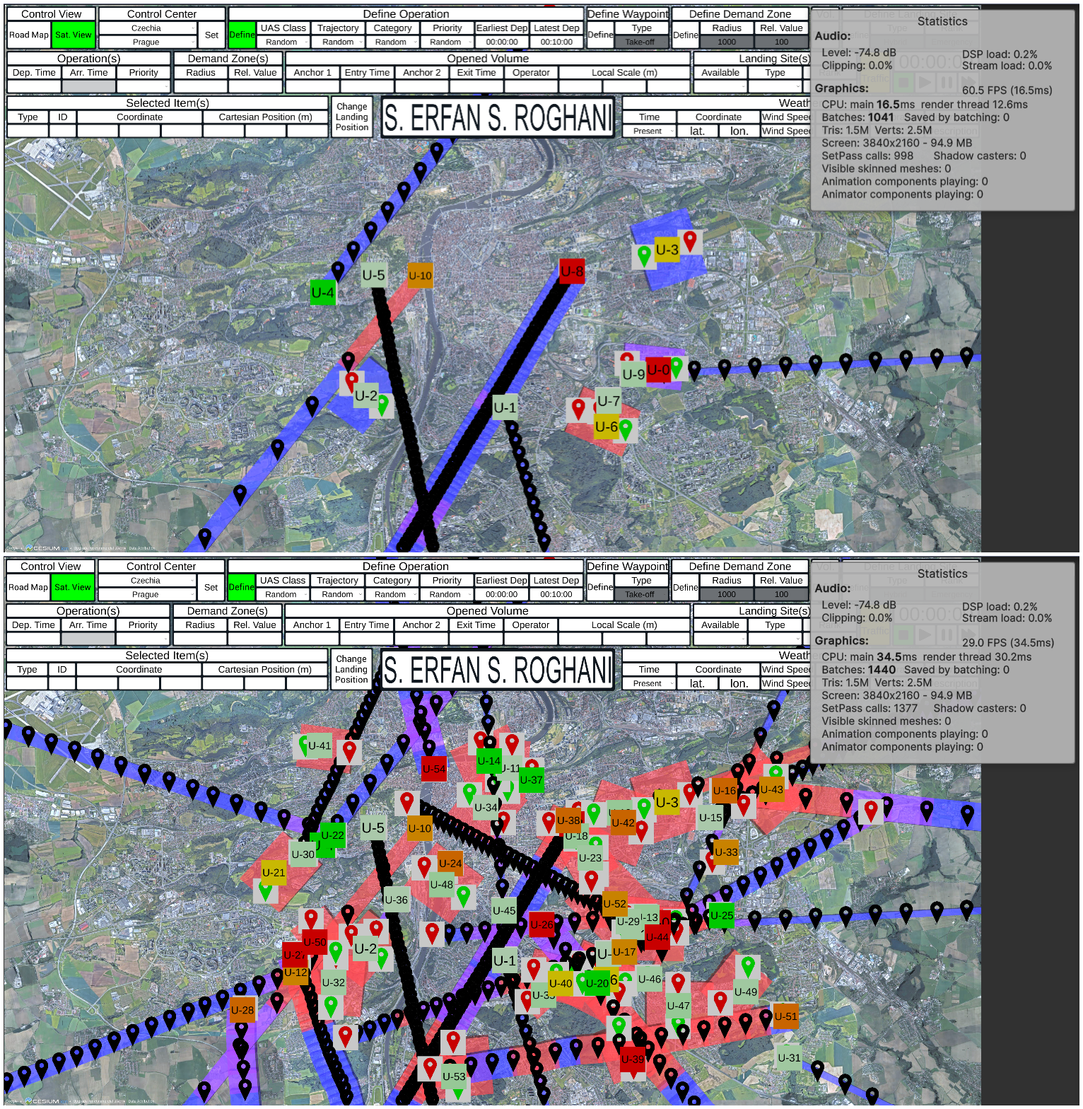

Figure 11 Frame Rate Comparison: Top – Conflict detection for 11 operations (211 total volumes) running at 60 FPS; Bottom – Conflict detection for 55 operations (750 total volumes) running at 29 FPS.

### Conclusion

The System Scalability Test demonstrates that the A-FPLAS framework scales effectively in dense urban environments under sudden increases in operational demand. The real-time conflict detection engine operates stably, and the A-FPLAS hierarchy is capable of proposing fair and feasible alternatives within the RTTA window in most cases.

The only observed limitation is the increase in resolution time when the number of conflicting volumes exceeds a critical threshold. This issue does not undermine the system's viability but highlights the need for either early invocation of the conflict resolution process or further optimization of the HRL agents.

Overall, the validation confirms that A-FPLAS is well-suited for autonomous trajectory management in high-density, real-world U-space contexts.

## Scenario 2: Integration with Dynamic Airspace

### 5.6.1 Description of the scenario

This scenario evaluates the ability of the Autonomous Flight Plan Approval System (A-FPLAS) to adapt to dynamically changing airspace conditions, particularly due to real-time weather updates—most notably, wind. The test is situated in the downtown area of Prague, Czechia, during peak business hours in a highly saturated urban U-space environment. Operations include a mix of deliveries, traffic monitoring, and aerial photography.

Key Scenario Characteristics:

* **Location**: Prague city center
* **Time**: Weekday peak operation period
* **Traffic Density**: High; 2–3 drone operations per hour with overlapping schedules
* **Trajectory Types**: Mixed (linear and area-based)
* **Environmental Dynamic**: Wind conditions influencing airspace structure in real time

The primary focus of this scenario is to assess the AI system's ability to incorporate dynamic weather-based constraints, specifically those derived from wind-related risks, and to adjust the trajectory approval logic accordingly.

### Objective

To evaluate the A-FPLAS system’s capability to:

* Integrate with external weather models (e.g., SINTEF's wind model)
* Translate wind data into actionable constraints (e.g., restricted zones)
* Recompute trajectory recommendations fairly and efficiently under dynamic conditions
* Maintain operator preferences and fairness logic during adaptation

### Simulation Setup

While the full integration with SINTEF’s wind model has not yet been completed, the simulator currently operates with synthetically defined restricted areas that emulate wind-induced constraints. The simulation environment is built in Unity, using Cesium for global 3D terrain and building visualization.

These restricted areas can be perceived as outputs from SINTEF or any third-party risk assessment model. Once available, A-FPLAS will receive this data via a direct API connection, allowing for automated access and real-time updates.

During the validation, wind-induced restricted areas are introduced into the airspace just before the Reasonable Time To Act (RTTA) window. These zones are represented as 4D volumes that may intersect planned operations, triggering the A-FPLAS hierarchy to intervene.

### Dynamic Integration Logic

Wind conditions are not directly interpreted in real time by the simulator. Instead, they are assumed to be processed externally, with the resulting geometric boundaries of no-fly zones sent to the simulator. These boundaries are then treated identically to conflict-inducing trajectories.

Once wind data indicates unacceptable operational risk—especially in cases where the operation would no longer be permitted even under a certified category—the airspace is flagged as restricted. If such a restriction intersects an active U-plan, A-FPLAS processes the zone as an incoming area-based trajectory and triggers conflict resolution.

The Strategy Selector Agent determines whether the conflict should be addressed using the Re-router or Re-scheduler agent, based on operator preferences and contextual features.

Although additional regulatory checks (such as validating pilot licenses or airworthiness certifications) would normally be required for certified category operations, these are acknowledged but not modeled in the simulation, as they involve administrative processes beyond the scope of HRL-driven trajectory approval.

### Metrics and System Behaviour

To evaluate performance and scalability under dynamic environmental constraints, the following metrics were tracked:

|  |  |  |
| --- | --- | --- |
| **Metric** | **Description** | **Value** |
| Wind-induced Conflicts | Number of conflicts triggered by restricted zones resulting from wind | 1 |
| Response Time | Time taken to generate an alternative trajectory from the moment of conflict | 11 seconds |
| System Performance Degradation | Any observed reduction in responsiveness or accuracy under dynamic loads | No |

**Observations:**

* The system's behavior in the presence of wind-induced restrictions was consistent with its behavior during trajectory-to-trajectory conflict resolution.
* As long as the resolution process began at least 10 minutes prior to activation, the system was able to generate a valid alternative within the 5-minute RTTA window.
* The A-FPLAS process did not significantly impact simulator frame rate or computational performance.

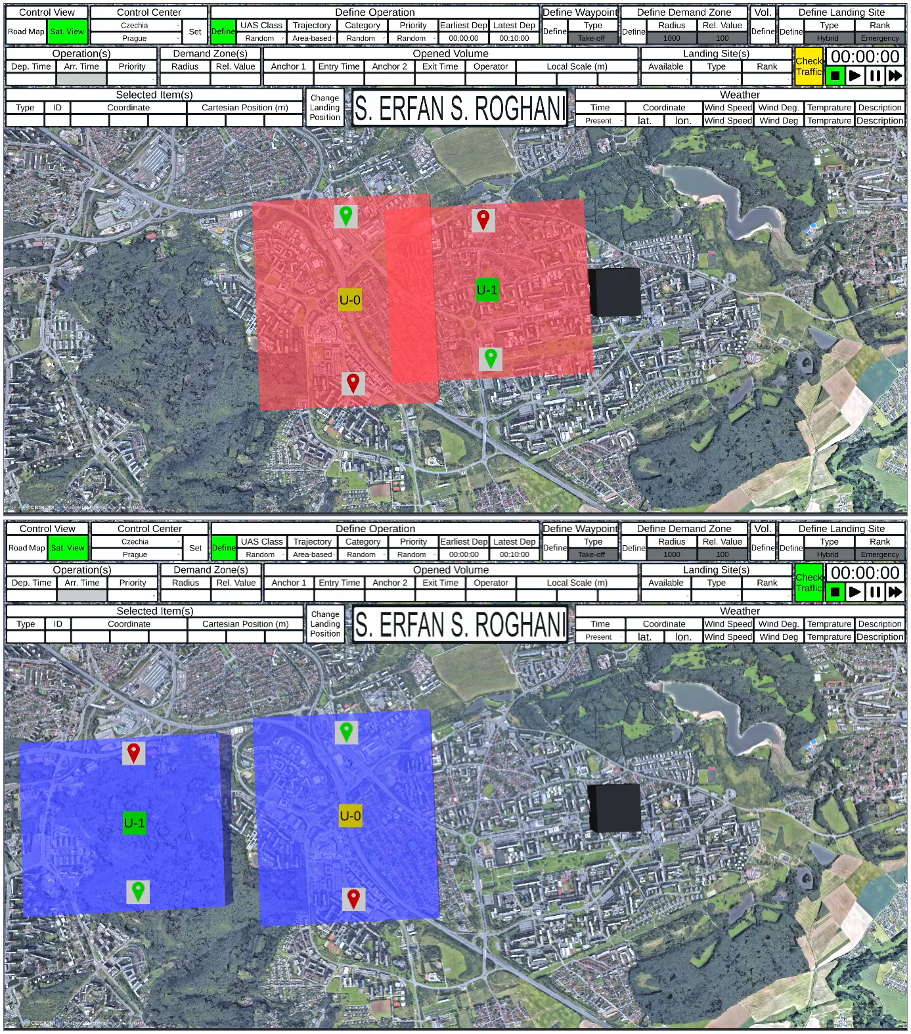

Figure 12 Respecting Wind-Induced Restriction: The area-based trajectory requested by the operator of UAS 1 (U1) is in conflict with that of UAS 0 (U0). Since the operator of U1 strongly prioritizes preserving the timing of the operation, the A-FPLAS framework opts to modify the geometry of the trajectory. In doing so, it avoids the wind-induced restricted area (shown in black) and shifts the trajectory to a less populated region. Top and bottom views illustrate the state of the operation before and after deconfliction.

### Fairness and Explainability

Despite the introduction of dynamic constraints, the A-FPLAS system retained its commitment to fairness and explainability. Since the same HRL agents are responsible for resolving both standard and wind-induced conflicts, the system continued to:

* Respect operator preferences (geometry vs. timing)
* Minimize flight time overpopulated areas
* Avoid high-demand zones likely to be used by other operators

SHAP-based explainability tools remain applicable in this context, offering insight into why certain alternatives were selected in response to environmental constraints.

### Conclusion

This validation scenario demonstrates that the A-FPLAS framework is capable of integrating dynamic airspace changes caused by weather conditions, even without a direct connection to SINTEF’s wind model. The system currently functions using proxy restricted areas, which can seamlessly be replaced with live weather-model outputs once the API integration is complete.

The system successfully adapts to changing conditions, maintains performance under pressure, and preserves its fairness logic across operator, population, and peer operator stakeholders. The only operational constraint is ensuring that conflict resolution for wind-induced restrictions is triggered early enough to meet RTTA deadlines. This highlights the need for proactive integration with dynamic models and further performance optimization.

The findings validate A-FPLAS as a viable solution for safe, scalable, and fair autonomous flight plan management in environments impacted by real-time weather dynamics.

## Scenario 3: Compliance and Safety Audit

### 5.7.1 Description of the Scenario

The final validation scenario evaluates the capacity of the A-FPLAS framework to enforce compliance with regulatory requirements and safety standards under complex operational conditions. As with previous scenarios, the test is conducted over the downtown area of Prague, Czechia, simulating high-density drone operations during a weekday peak hour. The airspace features a mix of delivery, traffic monitoring, and aerial photography missions.

Key Scenario Features:

* **Location**: Prague city center
* **Time**: Weekday peak operational window
* **Traffic Density**: High; 2–3 overlapping operations per hour
* **Trajectory Types**: Mixed (linear and area-based)
* **Regulatory Context**: Compliance with standard airspace rules and local regulations

This scenario focuses on whether flight plans approved or modified by A-FPLAS adhere to both operational safety rules and formal compliance protocols.

### Objective

To confirm that the A-FPLAS framework:

* Detects non-compliant or unsafe flight plans
* Prevents the approval of operations that violate airspace constraints
* Visually alerts users to violations during simulation
* Can be expanded to support full compliance integration through the UCIS platform

### Compliance Check in the Simulator

The validation focuses on two core regulatory checks:

1. **Trajectory Completeness**: Ensures that all submitted trajectories are spatially and temporally continuous.
2. **Restricted Area Intrusion**: Identifies operations that violate wind- or policy-defined no-fly zones.

**Trajectory Completeness**

To ensure a trajectory is valid:

* Each volume must connect seamlessly with the next, with no spatial or temporal gaps.
* The simulator checks this using the 4D volume format retrieved via the UCIS API.

During validation we discovered that, because there is currently no industry‑wide standard for U‑plan trajectories and volumes, UCIS has defined its own submission schema. In that schema the volume4D message represents an airspace block solely by minimum and maximum altitudes, which means pitch angles (climb or descent) cannot be expressed explicitly. To capture vertical profiles with changing pitch we therefore switched to the trajectory4D message, which lets us specify x‑, y‑ and z‑coordinates along the flight path.

Each waypoint in a trajectory4D plan includes a spatial_variation field, which is populated with the width, height, and length of the volume that begins at that waypoint. The final waypoint (the landing point) does not use this field.

**Restricted Area Intrusion**

Restricted zones are represented as area-based trajectories and treated as potential 4D conflicts. The simulator detects conflicts by evaluating whether the submitted trajectory overlaps in time and space with these restricted volumes.

### Safety Rule Enforcement

The simulator leverages Unity's physics engine to perform real-time spatial conflict detection. Each trajectory volume and restricted area is enclosed in an axis-aligned bounding box (AABB). Unity’s collision detection system can:

* Detect overlap between bounding boxes
* Determine if one volume is contained within another
* Maintain performance at 50 frames per second with 400 bounding boxes

This performance benchmark indicates robust support for dense environments without degradation.

### System Response to Violations

If a non-compliant or unsafe flight plan is detected:

* The simulator visually alerts the user (e.g., conflict with restricted areas, trajectory gaps)
* In future deployment, the system would label the plan as rejected, provide an explanation, and push this update through the UCIS API
* The user’s flight plan editor could retrieve this feedback and submit a corrected version

Importantly, the simulator’s HRL hierarchy is **only activated** for plans that are otherwise valid but suffer from a conflict. The system does not attempt to fix plans with basic structural or regulatory errors (e.g., incomplete volumes).

### Role of A-FPLAS in Compliance and Safety

The HRL agents play a critical role in ensuring compliance whenever a submitted plan intrudes on restricted airspace or conflicts with another operation. When invoked, they:

* Recommend an alternative trajectory that respects the restricted zone boundaries
* Strive to preserve operator preferences and fairness goals even when modifying the route

In this way, A-FPLAS is not just a conflict resolution tool—it actively enforces compliance through constraint-respecting action.

### Metrics and Performance Evaluation

The system tracks the following key metrics during the compliance audit:

|  |  |  |
| --- | --- | --- |
| **Metric** | **Description** | **Value** |
| Incomplete Trajectory Detection Average Time | Time taken to detect structural issues upon UCIS U-plan retrieval | 15 Seconds |
| Conflict Detection Frame Rate | Simulator frame rate while checking conflicts (target: 50 FPS with 400 volumes) | 48 FPS with 454 volumes |
| Visual Feedback Events | Number of warnings triggered (trajectory gaps, restricted area intrusions) | 13 warning for incomplete operations and 1 warning for restricted area intrusion |

These metrics confirm that the most computationally intensive task—4D spatial conflict detection—is well optimized. Simpler checks (e.g., validating flight category or strings) are trivial in computational cost and are excluded from performance analysis.

### Validation Results and Lessons Learned

The simulation confirms that A-FPLAS is capable of:

* Continuously validating trajectory completeness
* Preventing overlap with restricted areas in real-time
* Maintaining simulator responsiveness even under high operational loads
* Incorporating fallback mechanisms for user feedback

However, known edge cases exist. Specifically, traffic scenarios that require conflict or intrusion detection across more than 400 volumes or restricted areas can degrade the simulator’s frame rate. This potential degradation reflects a realistic bottleneck that may also affect future operational flight plan approval interfaces built on this engine.

To address this, optimization strategies are proposed:

* Focused development of a performance-optimized approval interface
* Decentralization of flight plan approval responsibilities
  + For instance, dividing the urban area of Prague into five zones
  + Assigning separate instances of the interface to five different users on five computers

This strategy reduces computational burden per instance and ensures system scalability without compromising accuracy or responsiveness.

The experience with UCIS API integration provided valuable insight into how data structure constraints (e.g., between volume4D and trajectory4D) can affect compliance logic and enforcement precision.

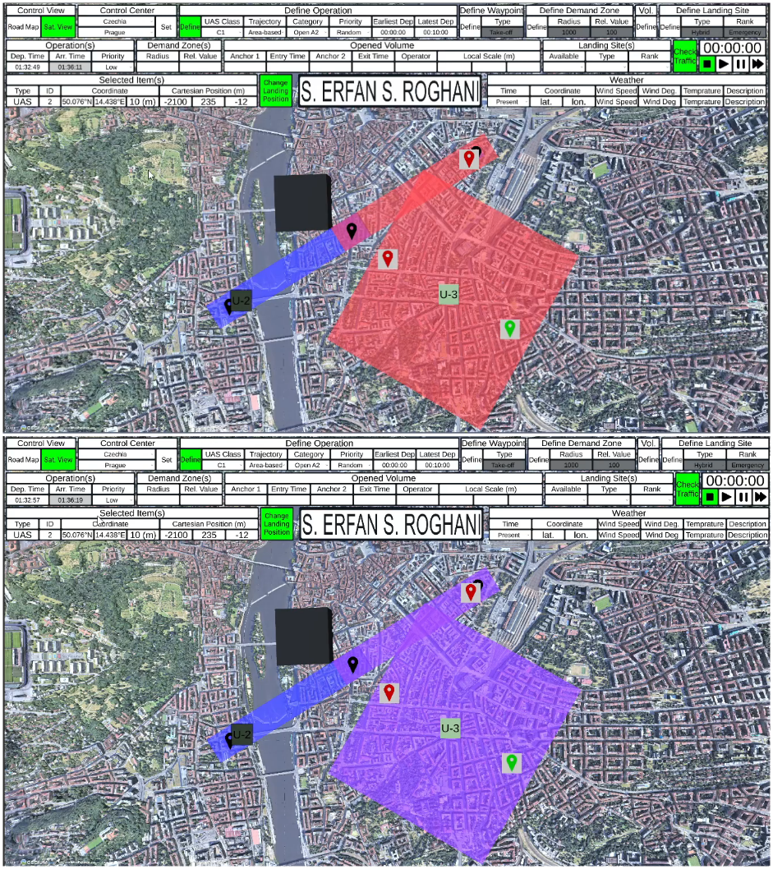

Figure 13 Respecting an Area Restricted by Rules: A low-priority linear trajectory is in conflict with an area-based trajectory. The A-FPLAS framework resolves the conflict by delaying the linear operation, ensuring compliance with a rule-based restricted area located in Prague, Czechia.

### Conclusion

This validation confirms that A-FPLAS can reliably enforce critical compliance and safety standards under realistic operational conditions. It ensures:

* 4D trajectory integrity
* Avoidance of restricted areas
* Respect for operator preferences and fairness

With its robust detection logic, flexible API integration, and HRL-based corrective mechanisms, A-FPLAS is well-positioned to serve as a core technology for future U-space service providers.

## Scenario 4: Flight Plan Recommendation

### 5.8.1 Scenario Description

This validation scenario tests the responsiveness of the A-FPLAS framework to sudden, high-impact changes in the airspace—specifically, emergency situations that require the immediate creation of no-fly zones. The environment remains consistent with prior scenarios: a high-density, peak-hour urban drone operation setting over Prague, Czechia.

Key Scenario Attributes:

* **Location**: Prague city center
* **Time**: Weekday, during peak business hours
* **Traffic Density**: High, with 2–3 overlapping operations per hour
* **Types of Operations**: Delivery, surveillance, real estate photography
* **Regulatory Framework**: Standard airspace regulations with emergency override logic

This scenario introduces a dynamic airspace constraint—a newly declared restricted area—requiring immediate response from the system.

### Objective

To test whether A-FPLAS can:

* React in real time to an emergency no-fly zone declaration
* Reroute affected UAS operations with minimal delay
* Avoid secondary conflicts through ordered re-prioritization
* Maintain fairness and airspace safety

### Emergency Event Simulation

In the simulated scenario, an emergency no-fly zone is triggered by a UAS deviating beyond its allowed operational threshold. The reason for deviation (e.g., C2 link loss, operator error, hostile behavior) is intentionally unspecified, as the focus lies on the airspace impact rather than the incident cause.

Upon deviation detection, a restricted area is declared:

* Modeled as a cube with 2000 m sides, centered on the last known UAS position
* Start time: moment of deviation detection
* Duration: default 4 hours, extendable based on situational control

This emergency event is modeled within Unity as a cubical volume to leverage efficient overlap detection using Oriented Bounding Boxes (OBBs). The system begins checking operations against the new restricted area starting 5 minutes before RTTA—which itself is 5 minutes before operation activation. This effectively means that only operations scheduled to begin 10 minutes or more after zone creation are processed for rerouting.

Flights already activated at the time of the emergency zone creation and potentially entering the newly declared restricted area are outside the scope of A-FPLAS. Since A-FPLAS is designed to support the Strategic Conflict Detection and Resolution service defined in IR (EU) 2021/664, the management of such dynamic in-flight conflicts is the responsibility of the Tactical Conflict Detection and Resolution service.

### System Response and Trajectory Management

Once the emergency no-fly zone is introduced, the system automatically:

1. Identifies all future operations that will intrude the zone based on their scheduled trajectories
2. Filters those with activation times at least 10 minutes away
3. Begins computing a recommendable alternative trajectory for each

Importantly, due to the indeterminate end time of the restricted area, the system bypasses the Strategy Selector Agent and directly calls the Re-Router Agent. This ensures all re-routed trajectories avoid the conflict zone spatially.

### Prioritization Logic

The system reroutes impacted operations in descending order of priority. Priority is defined by:

* The type of operation (e.g., critical delivery vs. routine surveillance)
* The flight plan submission time

Each re-routing:

* Ensures the modified trajectory avoids the restricted area
* Avoids new conflicts with any previously rerouted, higher-priority trajectory

This sequential and ordered rerouting approach prevents cascading conflicts and preserves fairness across operations.

### A-FPLAS Involvement

In this emergency scenario, the hierarchical agent framework adapts based on the zone’s temporal properties:

* If the end time is indeterminate (as is typical in emergencies), the system skips the Strategy Selector Agent and calls the Re-Router Agent directly.
* If the emergency zone has a definite end time, the full HRL hierarchy is followed.

This logic ensures rapid responsiveness without sacrificing the structured logic of the hierarchy in less time-sensitive situations.

### Key Performance Metrics

To evaluate system responsiveness and rerouting effectiveness, the following metrics are tracked:

|  |  |  |
| --- | --- | --- |
| **Metric** | **Description** |  |
| Time to Insert Restricted Zone | Time from incident detection to zone activation in simulation | < 1 second |
| Time to Recommend New Plan | Time taken by the system to generate an alternate trajectory | 70 seconds. |

### Observations and System Limitations

The A-FPLAS system performs well in reacting to dynamic emergencies, provided that operations are:

* Not yet within their RTTA window
* Scheduled far enough ahead for rerouting to be computed

However, two limitations are identified:

1. If an operation's RTTA has passed, the system cannot issue a recommendation. These cases must be handled at the tactical level, which is beyond A-FPLAS's intended scope.
2. If the available time between emergency declaration and operation activation is less than RTTA + computation time, the system may not complete rerouting in time. These, too, must be deferred to tactical intervention as a responsibility of the Tactical Conflict Detection and Resolution service.

These findings reinforce the need for a layered UTM architecture, where A-FPLAS handles pre-tactical approval while downstream systems handle last-minute or in-flight contingencies.

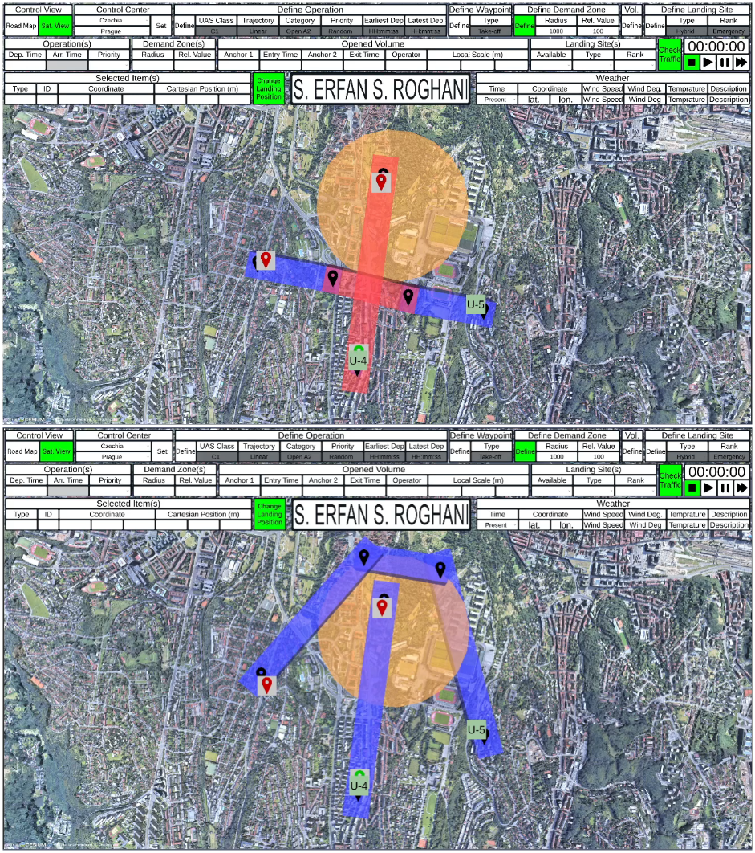

Figure 14 Recommending an Alternative Trajectory in the Presence of a High-Demand Zone: Taking social acceptability into account, the A-FPLAS platform chooses not to resolve the conflict by lowering the flight altitude. Instead, it horizontally deviates from the conflicting volume, ensuring that the modified trajectory remains distant from the center of the high-demand zone (indicated by the orange circle).

### Conclusion

This validation confirms that A-FPLAS is capable of detecting, processing, and responding to emergency no-fly zone declarations in real time. It efficiently reroutes only the necessary operations, maintains a priority-based order to prevent cascading conflicts, and adapts its agent hierarchy depending on the nature of the emergency.

Despite temporal limitations that prevent handling operations already within or too close to their RTTA, A-FPLAS successfully fulfils its role as a pre-tactical trajectory management and recommendation system. With appropriate hand-off to tactical-level components, the system supports safe and scalable integration of UAS into complex, high-density airspace environments.

# References

## 9.1 Applicable documents

1. U-space Concept of Operations (ConOps) - Edition 4. Retrieved from <https://www.sesarju.eu/node/4544>
2. Commission Implementing Regulation (EU) 2021/664 of 22 April 2021 on a regulatory framework for the U-space
3. Commission Implementing Regulation (EU) 2021/665 of 22 April 2021 amending Implementing Regulation (EU) 2017/373 as regards requirements for air traffic management/air navigation services providers and other air traffic management network functions in the U-space airspace designated in controlled airspace
4. Commission Implementing Regulation (EU) 2019/947 of 24 May 2019 on the rules and procedures for the operation of unmanned aircraft
5. Commission Implementing Regulation (EU) 2020/639 of 12 May 2020 amending Implementing Regulation (EU) 2019/947 as regards standard scenarios for operations executed in the specific category
6. Commission Implementing Regulation (EU) 2024/1111 on the operation of manned aircraft with vertical take-off and landing (VTOL) capabilities
7. ASTM F3548-21: Standard Practice for UAS Traffic Management (UTM) UAS Service Supplier (USS) Interoperability
8. ICAO Standards and Recommended Practices (SARPs). Retrieved from https://www.icao.int
9. JARUS Specific Operations Risk Assessment (SORA) Guidelines. Retrieved from https://www.jarus-rpas.org
10. EASA Easy Access Rules for the Standardised European Rules of the Air (SERA). Retrieved from <https://www.easa.europa.eu>
11. BURDI Project - Initial CONOPS 00.03 Retrieved from <https://www.burdi.eu/conops/>

## Reference documents

[12] Gao, W., Yu, Z., Wang, L., Cui, H., Guo, B., & Xiong, H. (2024). Hierarchical Deep Reinforcement Learning for Computation Offloading in Autonomous Multi-Robot Systems. *IEEE Robotics and Automation Letters*.

[13] Huang, Z., Liu, Q., & Zhu, F. (2023). Hierarchical reinforcement learning with adaptive scheduling for robot control. *Engineering Applications of Artificial Intelligence*, 126, 107130.

[14] Liu, X., Wang, G., Liu, Z., Liu, Y., Liu, Z., & Huang, P. (2023). Hierarchical reinforcement learning integrating with human knowledge for practical robot skill learning in complex multi-stage manipulation. *IEEE Transactions on Automation Science and Engineering*. [15] Ma, X., Yuan, Y., & Guo, L. (2024). Hierarchical Reinforcement Learning for UAV-PE Game With Alternative Delay Update Method. *IEEE Transactions on Neural Networks and Learning Systems*.

[16] Chang, T., Neshatian, K., & Atlas, J. (2024). Sample Efficient Hierarchical Reinforcement Learning for the Game. *Proceedings of Ninth International Congress on Information and Communication Technology: ICICT 2024, London, Volume 9*, 419. Springer Nature.

[17] Zhu, A., He, H., Yang, Y., Zheng, Z., & Shao, J. (2024). Hands-Free: Action Abstraction With Hierarchical Reinforcement Learning in Text-Based Games. *IEEE Transactions on Consumer Electronics*.

[18] Aleksey, S., & Panov, A. I. (2020). Hierarchical actor-critic with hindsight for mobile robot with continuous state space. *Advances in Neural Computation, Machine Learning, and Cognitive Research III: Selected Papers from the XXI International Conference on Neuroinformatics, October 7-11, 2019, Dolgoprudny, Moscow Region, Russia*, 62-70.

[19] Min, C., & Song, J. (2022). Hierarchical End-to-end Control Policy for Multi-degree-of-freedom Manipulators. *International Journal of Control, Automation and Systems*, 20(10), 3296-3311.

[20] Nethala, S. S. P. (2023). *Autonomous harvesting via hierarchical reinforcement learning in dynamic environments* (Master's thesis, Texas A&M University-Corpus Christi).

[21] Lundberg, S. (2017). A unified approach to interpreting model predictions. *arXiv preprint arXiv:1705.07874*.

[22] Lemaire, J. (1991). Cooperative game theory and its insurance applications. *ASTIN Bulletin: The Journal of the IAA*, 21(1), 17-40. Cambridge University Press.

[23] Paneru, B., Paneru, B., Sapkota, S. C., & Poudyal, R. (2024). Enhancing healthcare with AI: Sustainable AI and IoT-Powered ecosystem for patient aid and interpretability analysis using SHAP. *Measurement: Sensors*, 36, 101305.

[24] Kumar, S., Vishal, M., & Ravi, V. (2022). Explainable reinforcement learning on financial stock trading using SHAP. *arXiv preprint arXiv:2208.08790*.

[25] Onyekpe, U., Lu, Y., Apostolopoulou, E., Palade, V., Eyo, E. U., & Kanarachos, S. (2022). Explainable machine learning for autonomous vehicle positioning using SHAP. In *Explainable AI: Foundations, Methodologies and Applications* (pp. 157-183). Springer.

[26] Juozapaitis, Z., Koul, A., Fern, A., Erwig, M., & Doshi-Velez, F. (2019). Explainable reinforcement learning via reward decomposition. *IJCAI/ECAI Workshop on explainable artificial intelligence*.

[27] Marthi, B. (2007). Automatic shaping and decomposition of reward functions. *Proceedings of the 24th International Conference on Machine Learning*, 601-608.

[28] Lin, Z., Zhao, L., Yang, D., Qin, T., Liu, T., & Yang, G. (2019). Distributional reward decomposition for reinforcement learning. *Advances in Neural Information Processing Systems*, 32.

[29] Unisphere U-space Weather Information Service <https://unisphere.io/solutions/u-space-weather-service>

[30] Acceptable Means of Compliance and Guidance Material to Regulation (EU) 2021/664 on a regulatory framework for the U-space, EASA, 16 December 2022.

1. Representatives of all the beneficiaries involved in the project
2. Representatives of the beneficiaries involved in the project